**SMT. TANUBEN & DR. MANUBHAI TRIVEDI COLLEGE OF INFORMATION SCIENCE SURAT**

**(BCA SELF FINANCED)**

**Affiliated to**

**VEER NARMAD SOUTH GUJARAT UNIVERSITY, SURAT**

**PROJECT ON**

**“Hostel Management System “**

**As Partial Requirement for The**

**Degree Of Bachelor of Computer Application (B.C.A.)**



**Year : 2022 – 23**

**GUIDED BY:                                       SUBMITTED BY:**

**Bhautika R. Patel                                Zeba R. Pothiyawala**

**Index**

|  |  |  |
| --- | --- | --- |
| **SR . NO .** | **DESCRIPTION** | **PAGE NO .** |
| **01** | Introduction | 03 |
| **02** | Scope & Objectives | 04 |
| **03** | Tools & Technology | 05 |
| **04** | Use – Case Diagram | 06 |
| **05** | ER – Diagram | 09 |
| **06** | Modules & its Functionality | 10 |
| **07** | Table Structure | 11 |
| **08** | Screenshots | 14 |
| **09** | Future Enhancement | 29 |
| **10** | References | 30 |

**Introduction**

Hostel Management System (HMS) is web-based system for managing various resources in the hostel.

As the name specifies "HOSTEL MANAGEMENT SYSTEM" is software developed for managing various resources in the hostel. For the past few years, the number of educational institutions is increasing rapidly. Thereby the number of hostels is also increasing for the accommodation of the students studying in this institution. And hence there is a lot of strain on the person who are running the hostel and software’s are not usually used in this context. This particular project deals with the problems on managing a hostel and avoids the problems which occur when carried manually.

HMS is supposed to have the following features:

handle the resources of admin, warden, and inmate.

The hostel booking system is developed in favour of the hostel management team which helps then to save the records of the students about their rooms and other things it helps them for the manual work from which it is very difficult to find the record of the students and the information about those ones who had left the hostel years before.



This solution is developed on the plight of the hostel management team Through this they cannot require so efficient person to handle and manage the affairs of the students in the hostel all you need to do is to login as admission of all the students who have obtained and registered their hostel from click verify to ascertain their eligibility and allocate them to the available hostel identification of the problems of the existing hostel management leads to the development of computerized solution.

**Scope & Objectives**

* To deal with Hostel Management System in an easy way and an efficient mannered.
* Create strong and secrete data base that allow for any connection in a secret way, to prevent any outside or inside attacks.
* To provide a quick response with very accurate information as and when required.
* To make the present manual system more interactive, speedy and user friendly.
* Reduce the cost of maintenance
* Maintain the students as hostellers and waiting list students separately.
* Student will no longer apply for their hostels manually.
* To know number of items (e.g.: bed, chairs) given to student staying in the hostel.
* Automatically insert student's details to the hosteller's record when the allotment is confirmed by the admin and deleted when vacation is conformed or after the course end date.
* Students can register their complaints.
* To ensure that the number of students staying in a room does not exceed specified limit.

**Tools & Technology Used**

✪ **Frontend Language :**

**HTML**

**CSS**

**php**

✪ **Backend Language :**

**MYSQL**

✪ **Additional Language :**

**jQuery**

**JavaScript**

**Software Requirement**

✪ **Visual Studio Code**

✪ **XAMPP**

**Use – Case Diagram**

**🗹 Use Case Diagram for Admin in “Hostel Management System “**

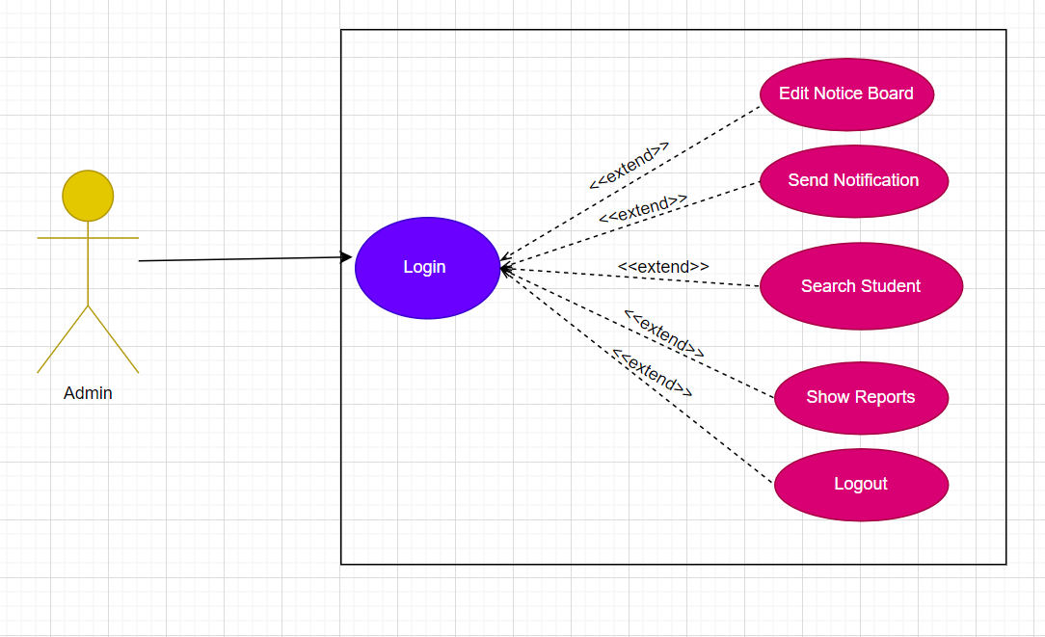

**🗹 Use Case Diagram for Warden in “Hostel Management System “**

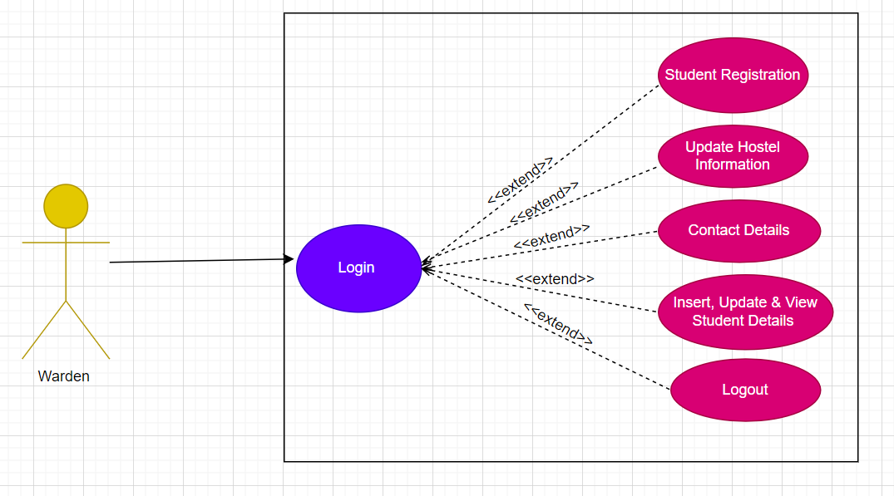

**🗹 Use Case Diagram for Inmate in “Hostel Management System “**

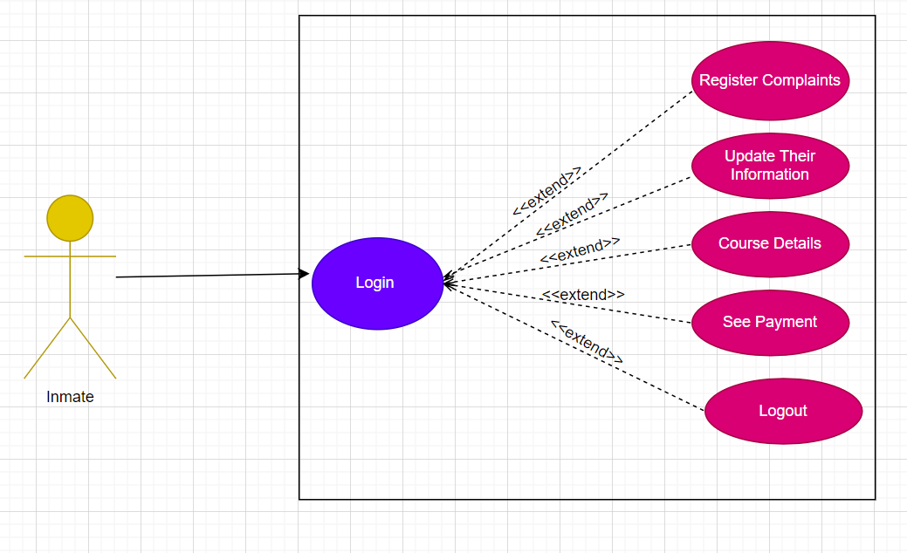

**ER Diagram**

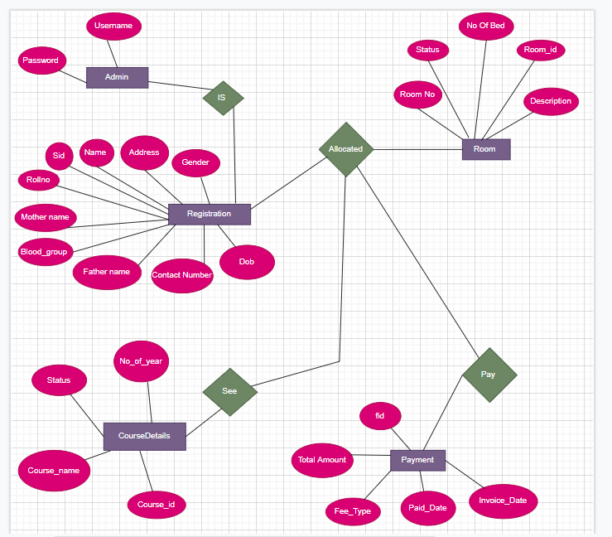

**Modules & Its Functionality**

**Admin**

* Login
* Edit notice board
* Send notification
* Search student
* Show reports
* Logout

**warden**

* Login
* Registration of students
* See contact details
* Update student data
* Update hostel information
* Logout

**Inmate**

* Login
* Register their complaints
* See paid fees
* Change the information
* See course details
* Logout

**Table Structure**

**Table 1 : tbladmin**

|  |  |  |  |
| --- | --- | --- | --- |
| **NO** | **FIELD NAME** | **DATA TYPE** | **CONSTRAIN** |
| 1 | EmailID | varchar(50) | NOT NULL |
| 2 | Password | Varchar(40) | NOT NULL |

**Table 2 : tblwarden**

|  |  |  |  |
| --- | --- | --- | --- |
| **NO** | **FIELD NAME** | **DATA TYPE** | **CONSTRAIN** |
| 1 | EmailID | varchar(50) | NOT NULL |
| 2 | Password | Varchar(40) | NOT NULL |

**Table 3 : registration**

|  |  |  |  |
| --- | --- | --- | --- |
| **NO** | **FIELD NAME** | **DATA TYPE** | **CONSTRAIN** |
| 1 | sid | Int(11) | AUTO_INCREMENT ,  Primary key |
| 2 | password | varchar(30) | NOT NULL |
| 3 | name | Varchar(40) | NOT NULL |
| 4 | rollno | Int(30) | NOT NULL |
| 5 | EmailID | varchar(40) | NOT NULL |
| 6 | dob | date | NOT NULL |
| 7 | father_name | varchar(40) | NOT NULL |
| 8 | mother_name | varchar(40) | NOT NULL |
| 9 | gender | varchar(30) | NOT NULL |
| 10 | address | Text | NOT NULL |
| 11 | contact_no | varchar(50) | NOT NULL |
| 12 | parents_no | varchar(50) | NOT NULL |
| 13 | blood_group | varchar(40) | NOT NULL |
| 14 | image | text | NOT NULL |

**Table 4 : room**

|  |  |  |  |
| --- | --- | --- | --- |
| **NO** | **FIELD NAME** | **DATA TYPE** | **CONSTRAIN** |
| 1 | room_id | Int(11) | AUTO_INCREMENT ,  Primary key |
| 2 | room_no | Varchar(40) | NOT NULL |
| 3 | no_of_beds | Int(11) | NOT NULL |
| 4 | description | Varchar(40) | NOT NULL |
| 5 | status | Varchar(30) | NOT NULL |

**Table 5 : fee**

|  |  |  |  |
| --- | --- | --- | --- |
| **NO** | **FIELD NAME** | **DATA TYPE** | **CONSTRAIN** |
| 1 | Fid | Int(11) | Primary key |
| 2 | paiddate | date | NOT NULL |
| 3 | invoicedate | date | NOT NULL |
| 4 | feeType | Varchar(40) | NOT NULL |
| 5 | totalFee | float | NOT NULL |

**Table 6 : course**

|  |  |  |  |
| --- | --- | --- | --- |
| **NO** | **FIELD NAME** | **DATA TYPE** | **CONSTRAIN** |
| 1 | course_id | Int(11) | AUTO_INCREMENT ,  Primary key |
| 2 | course_name | Varchar(40) | NOT NULL |
| 3 | no_of_year | Int(11) | NOT NULL |
| 4 | status | Varchar(20) | NOT NULL |

**Table 7 : msg**

|  |  |  |  |
| --- | --- | --- | --- |
| **No** | **FIELD NAME** | **DATA TYPE** | **CONSTRAIN** |
| 1 | no | Int(11) | AUTO_INCREMENT |
| 2 | message | TEXT | NOT NULL |

**Screenshots**

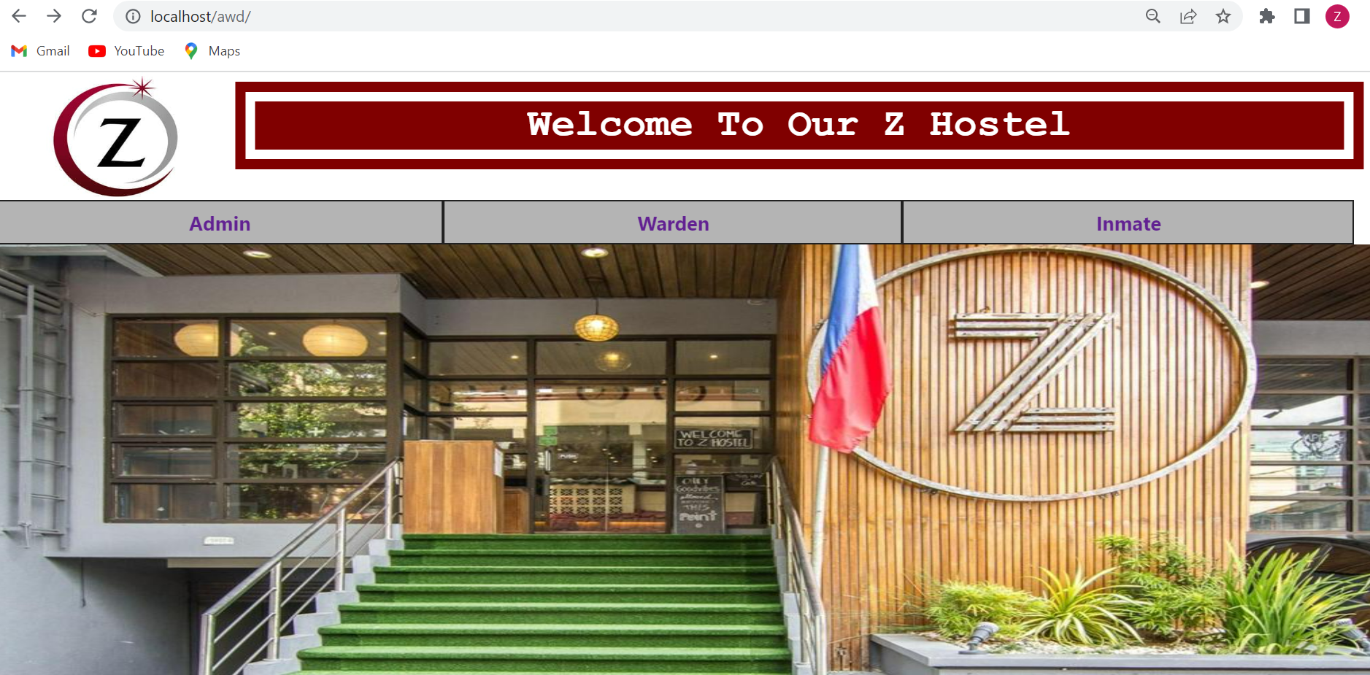

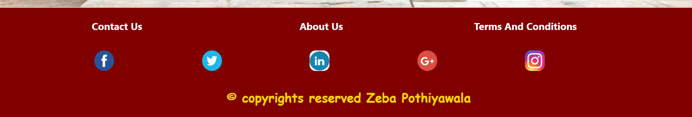

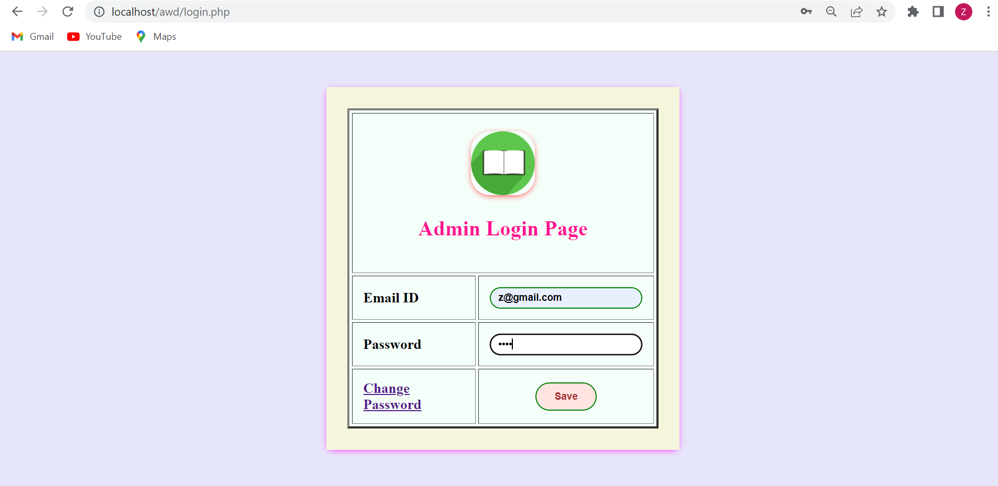

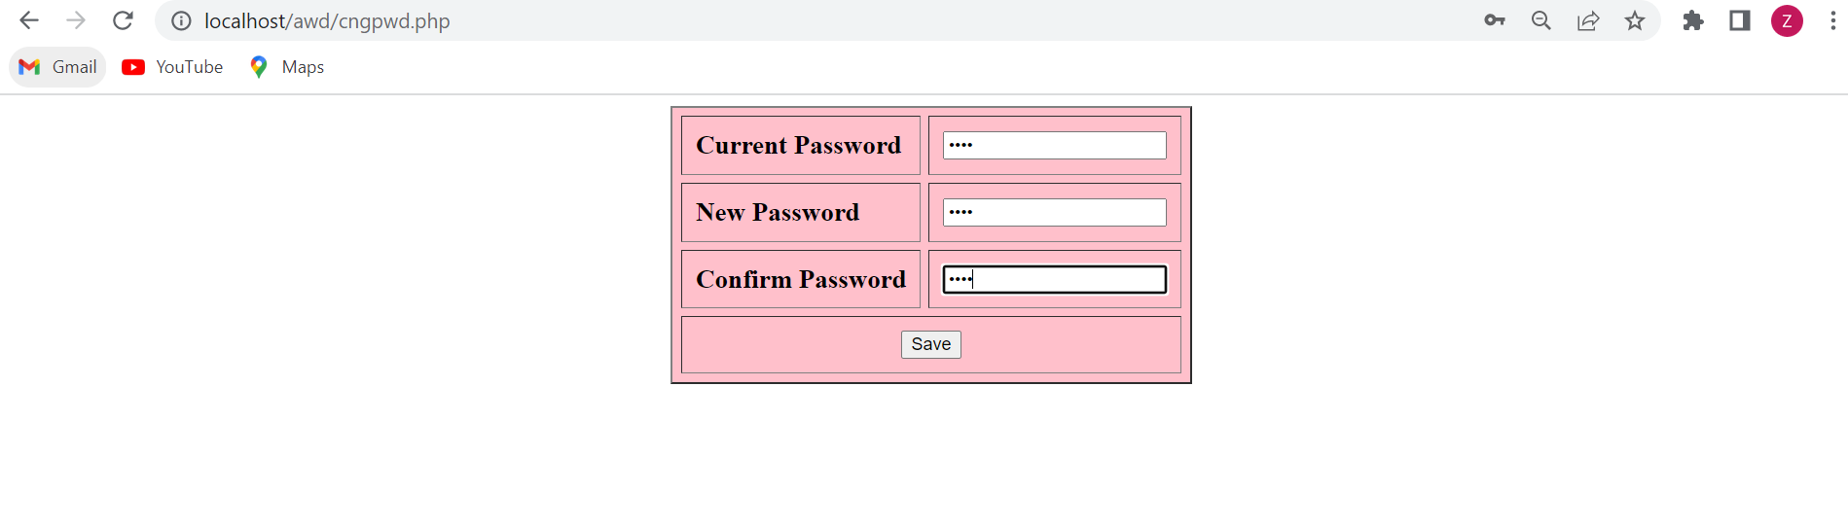

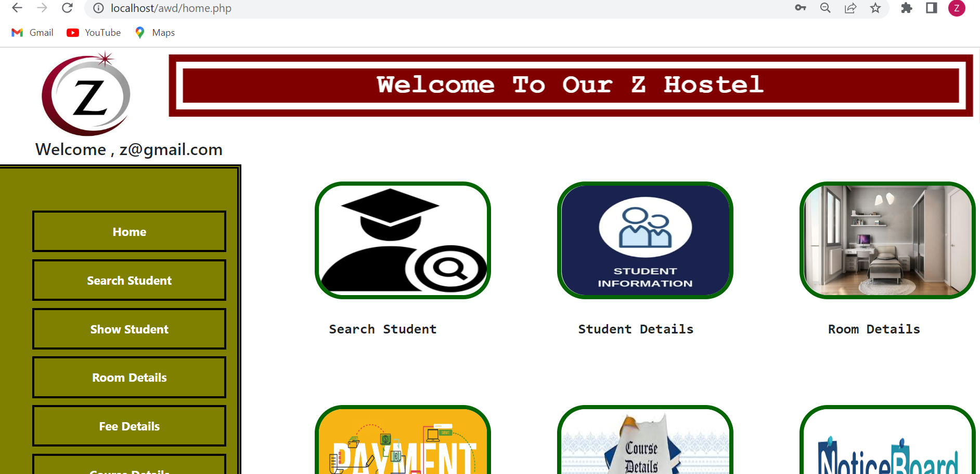

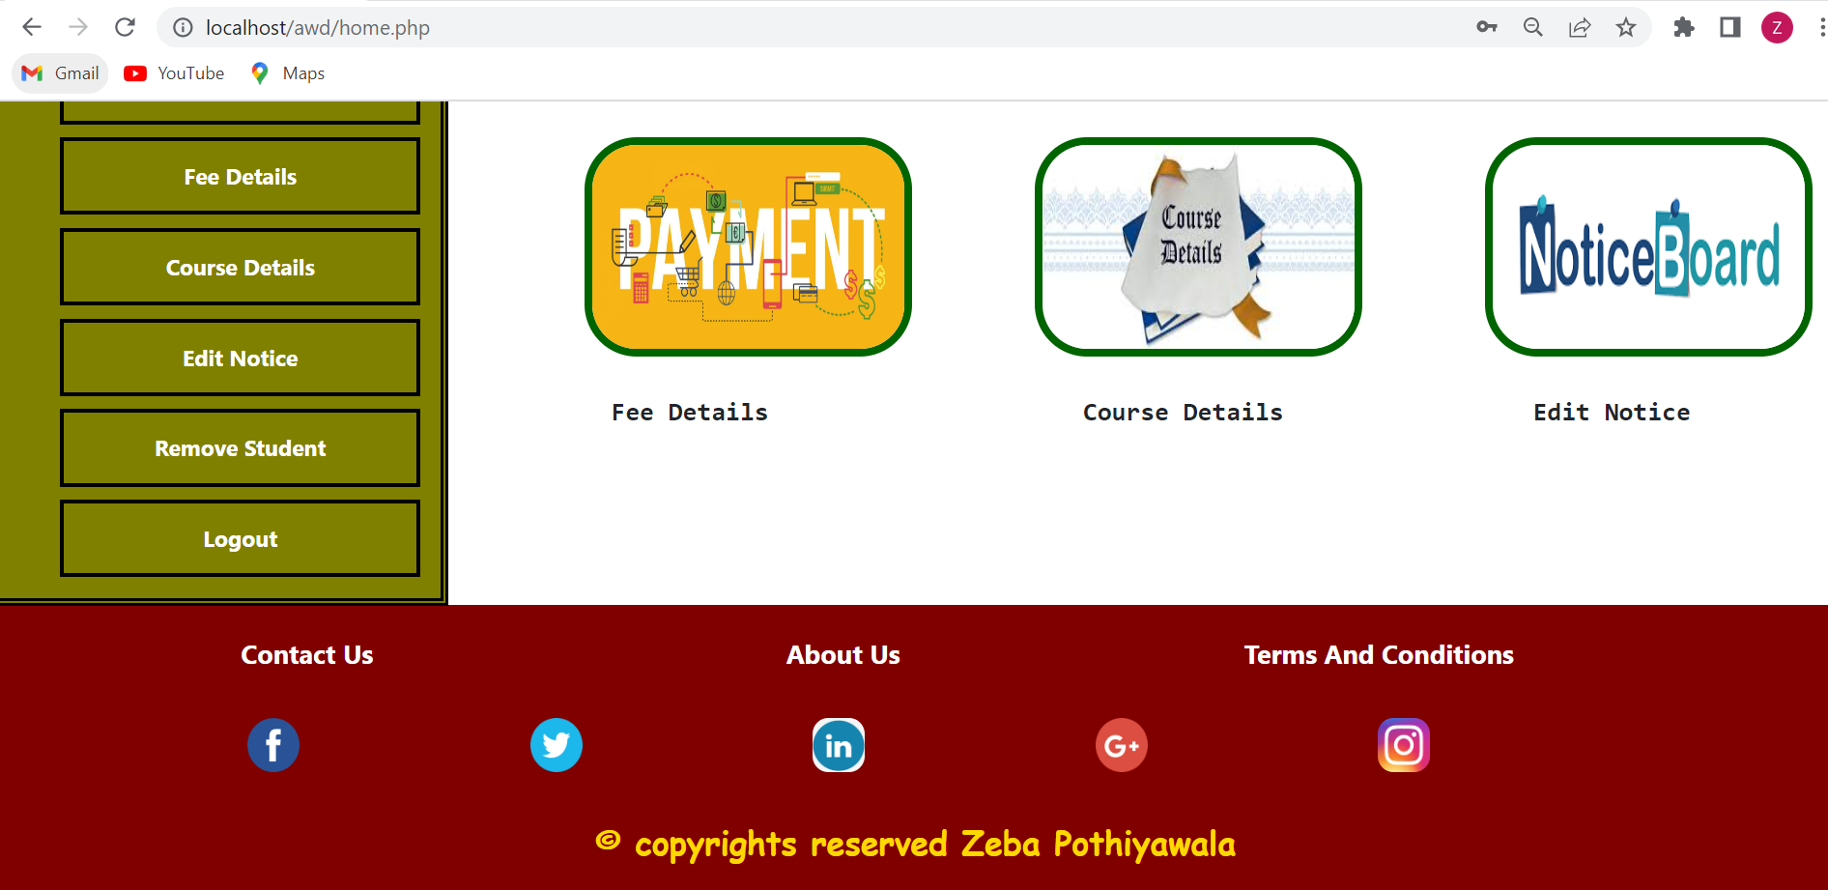

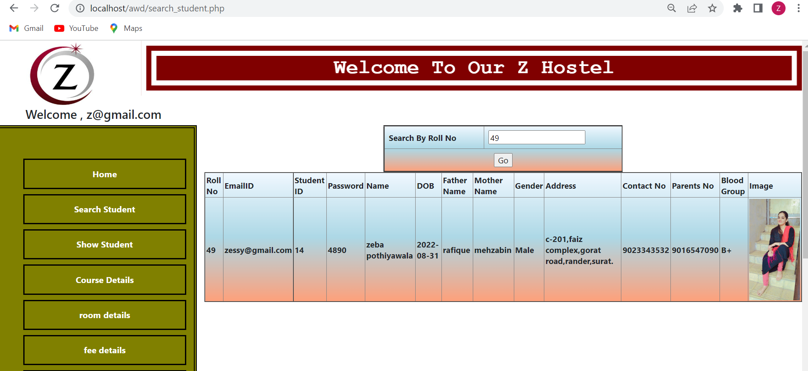

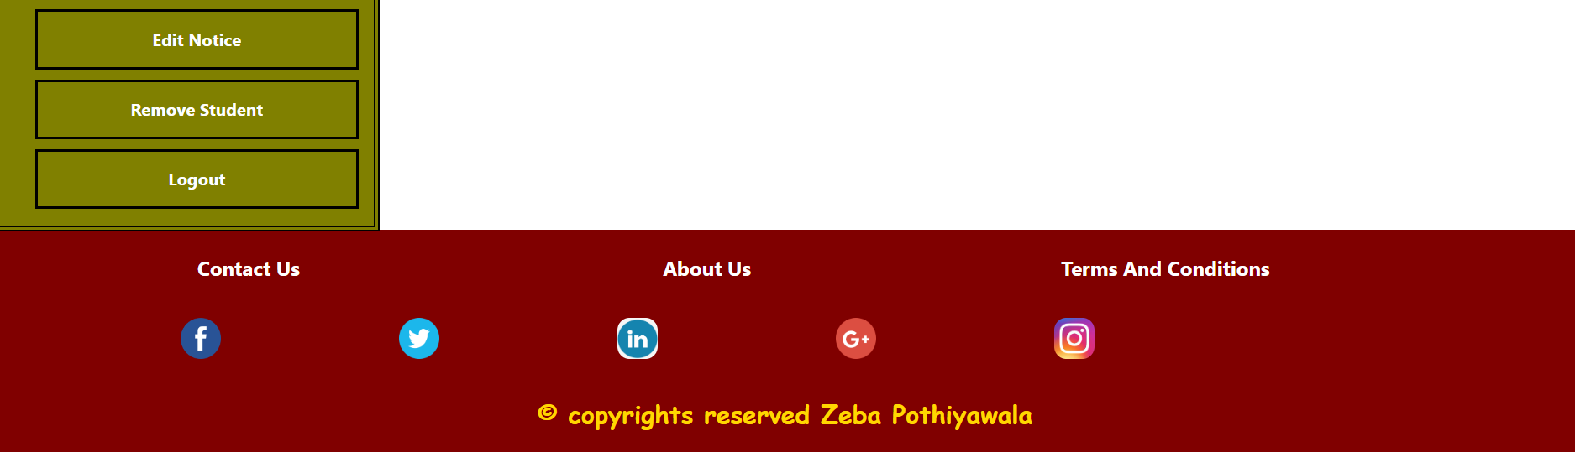

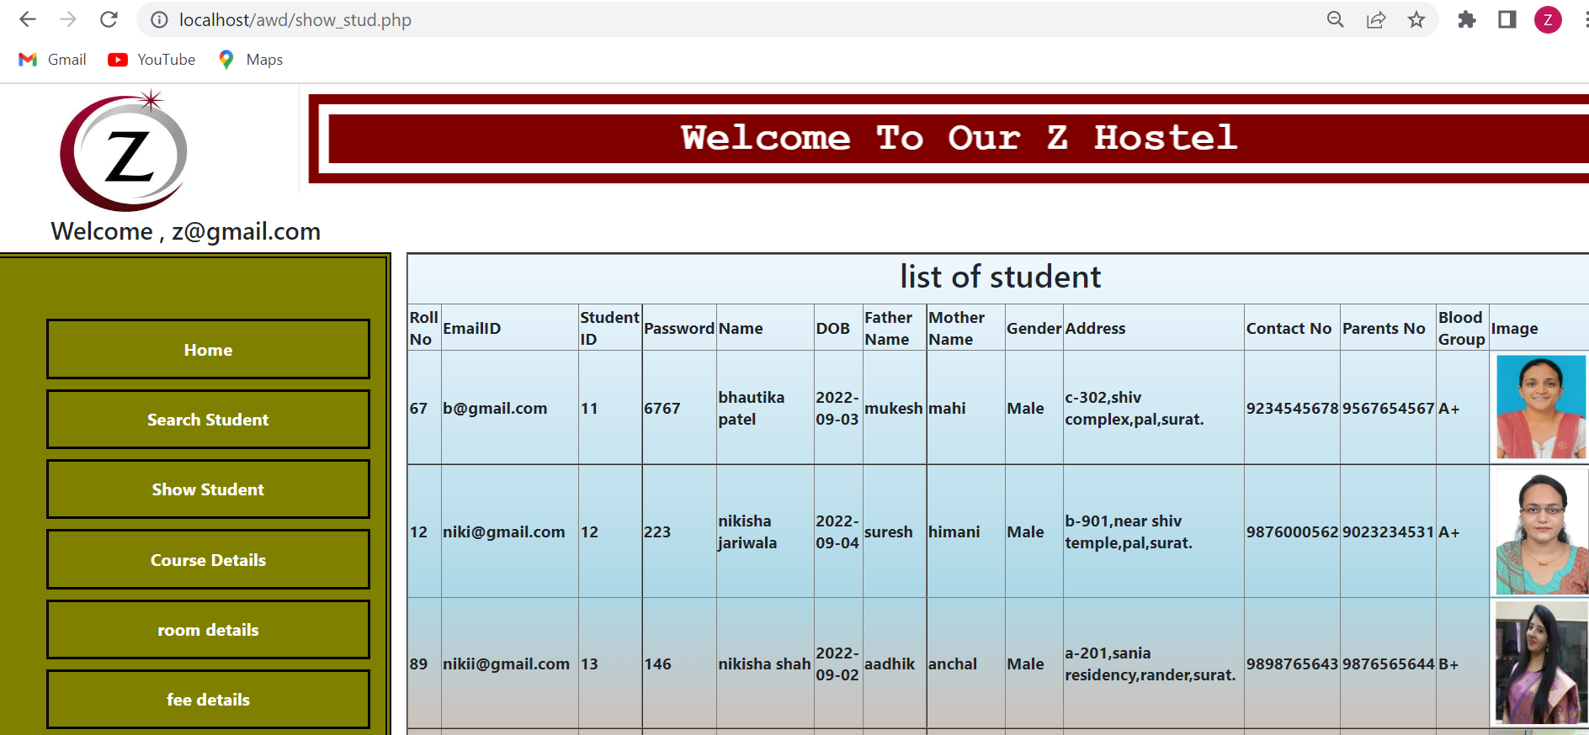

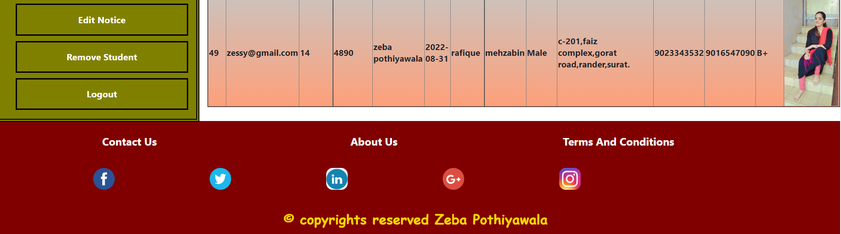

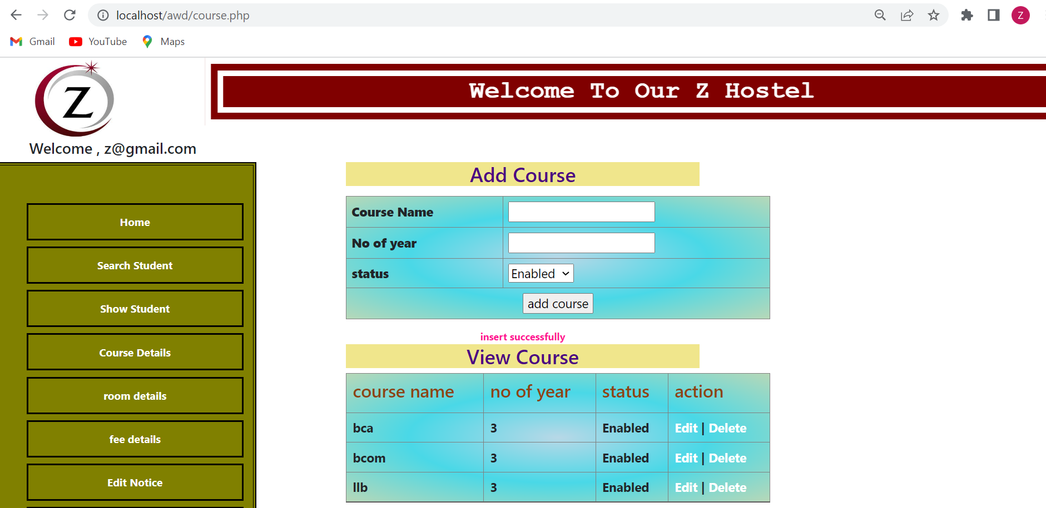

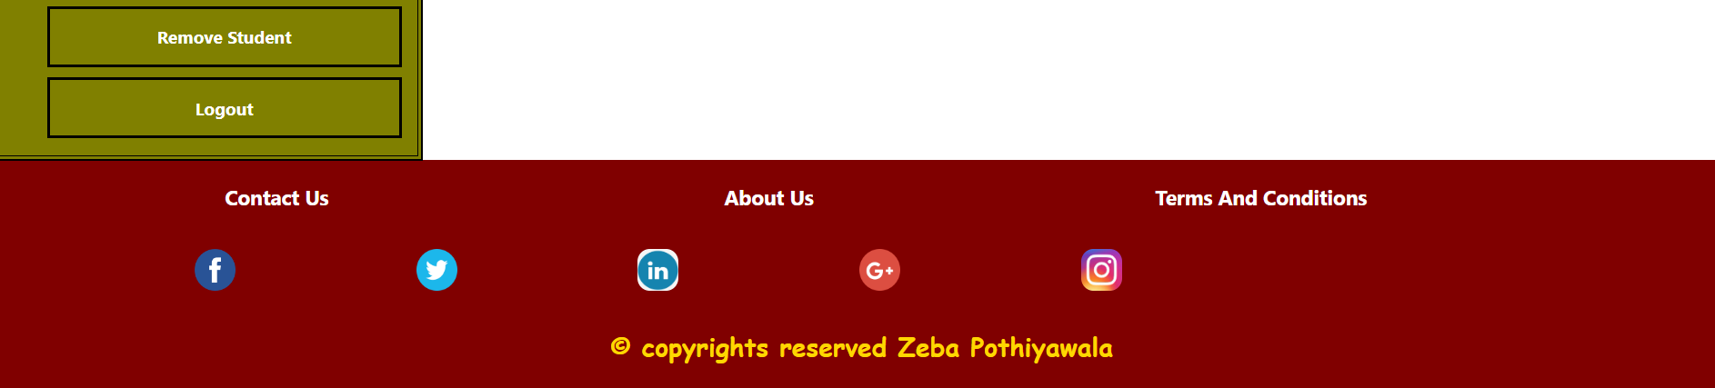

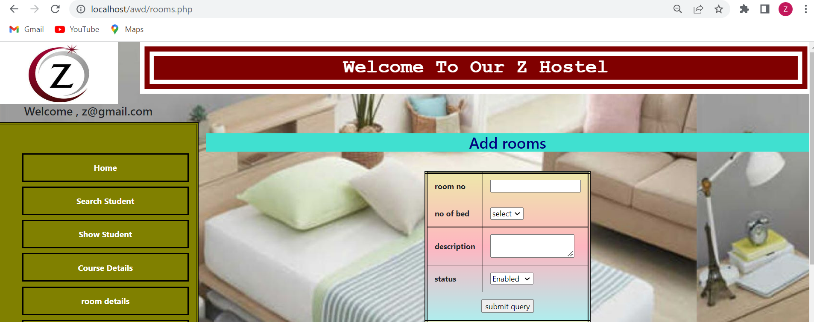

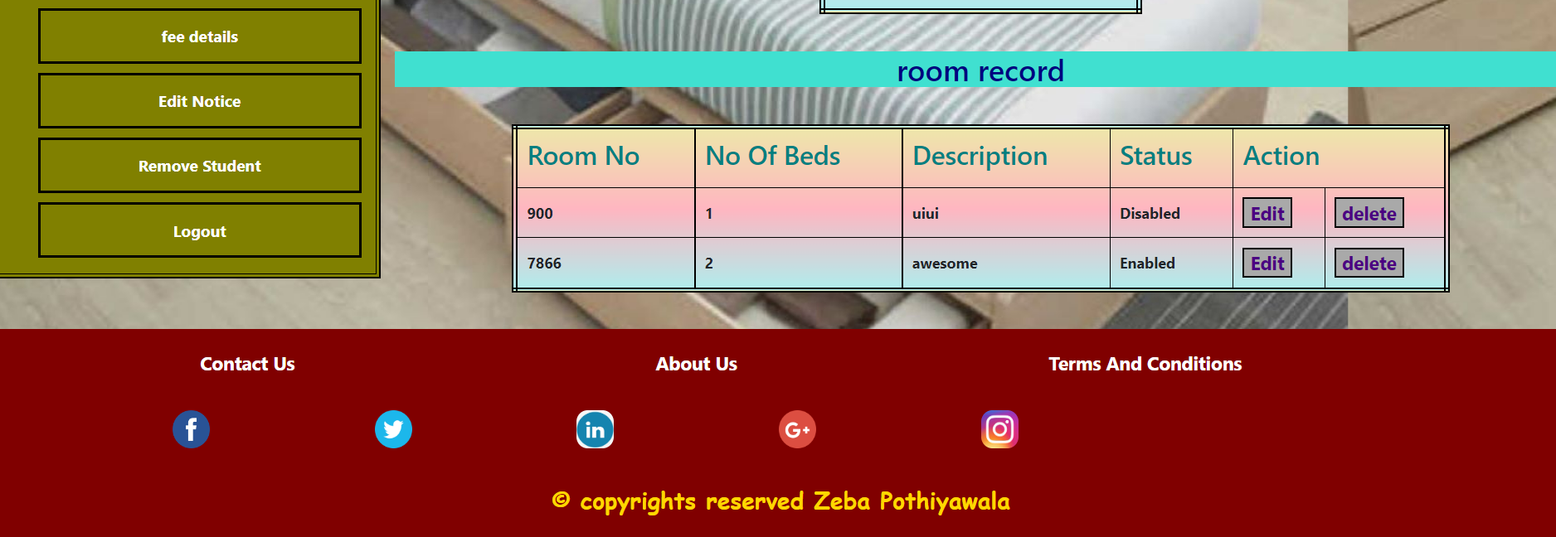

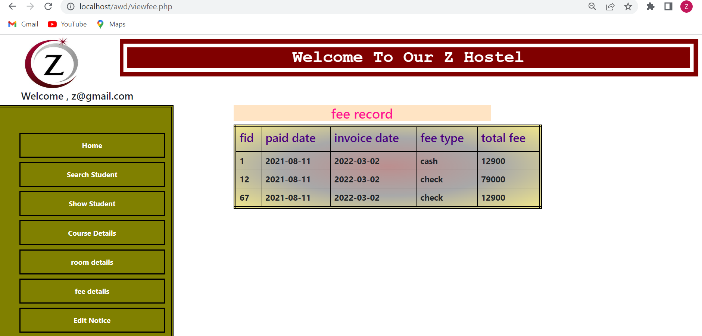

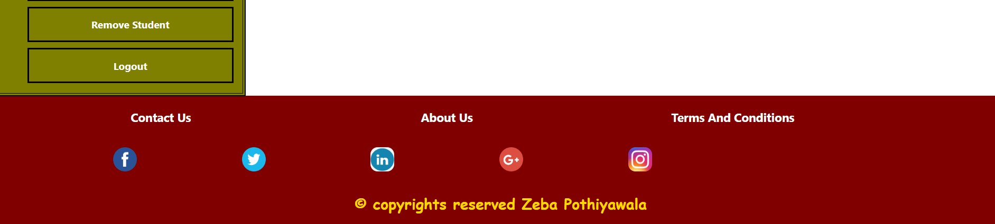

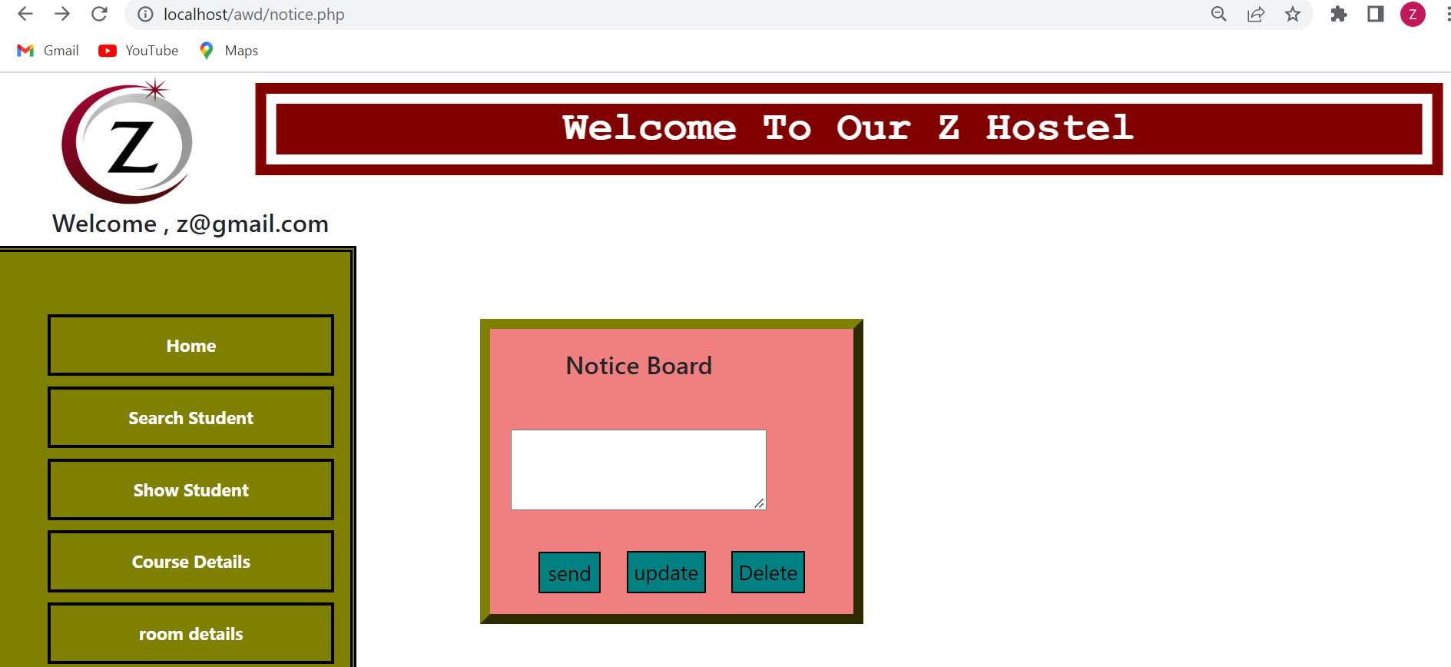

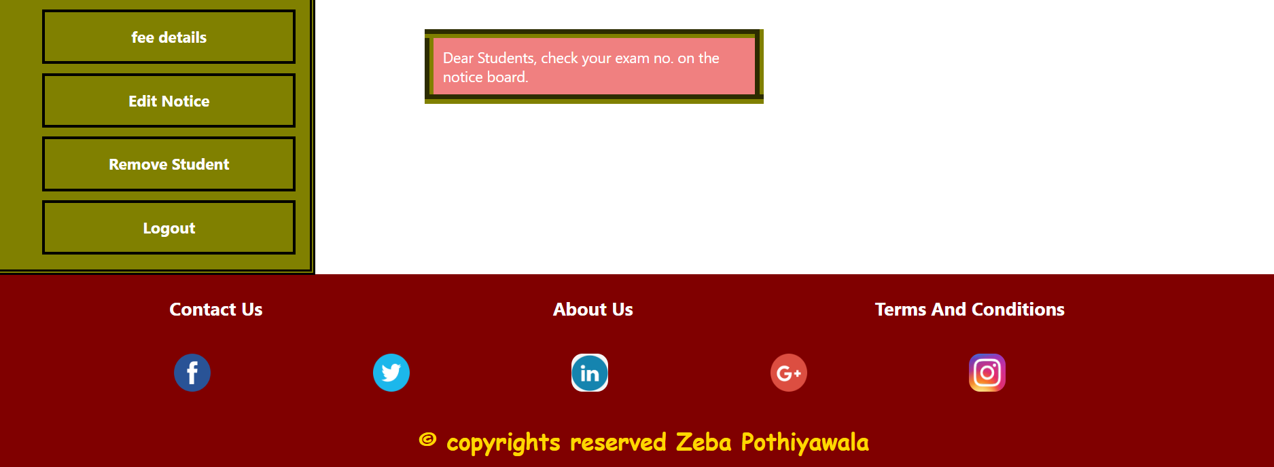

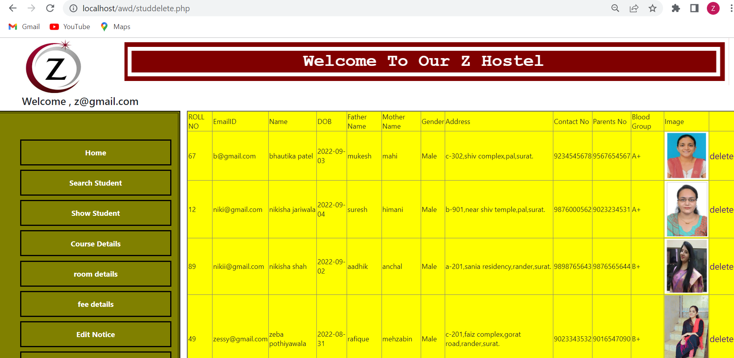

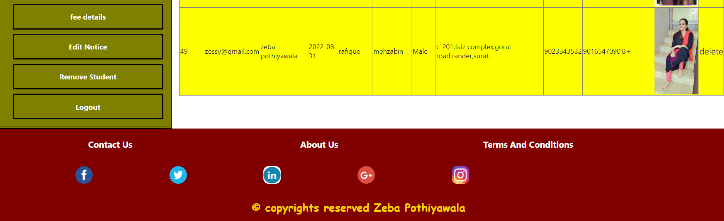

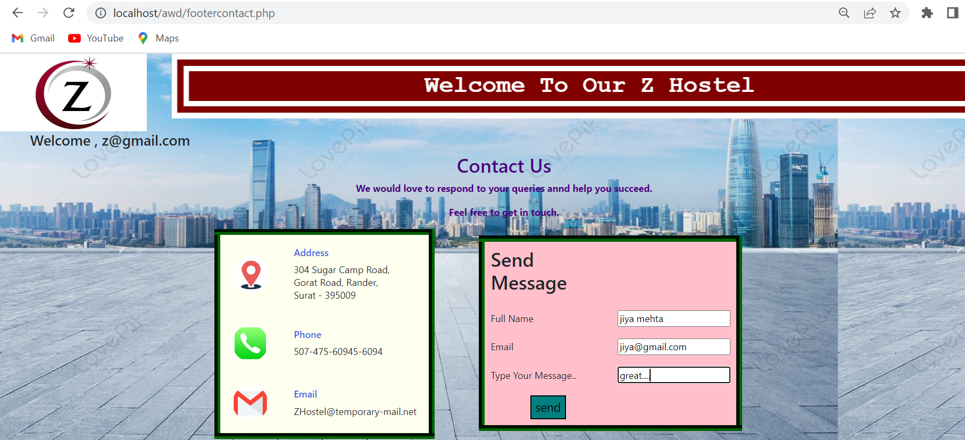



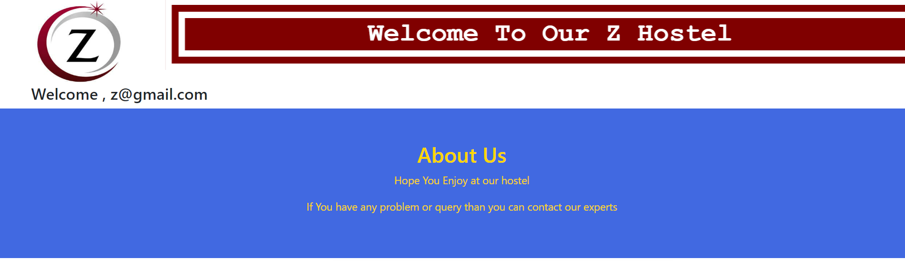





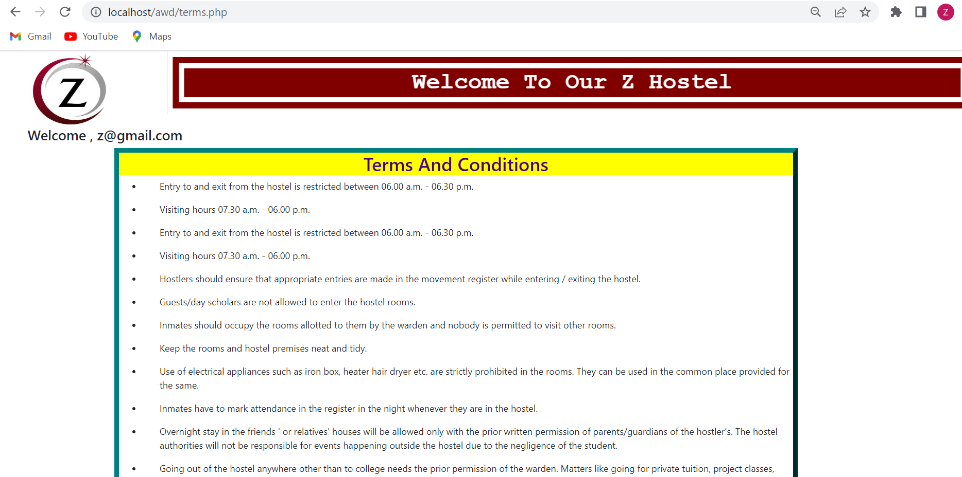

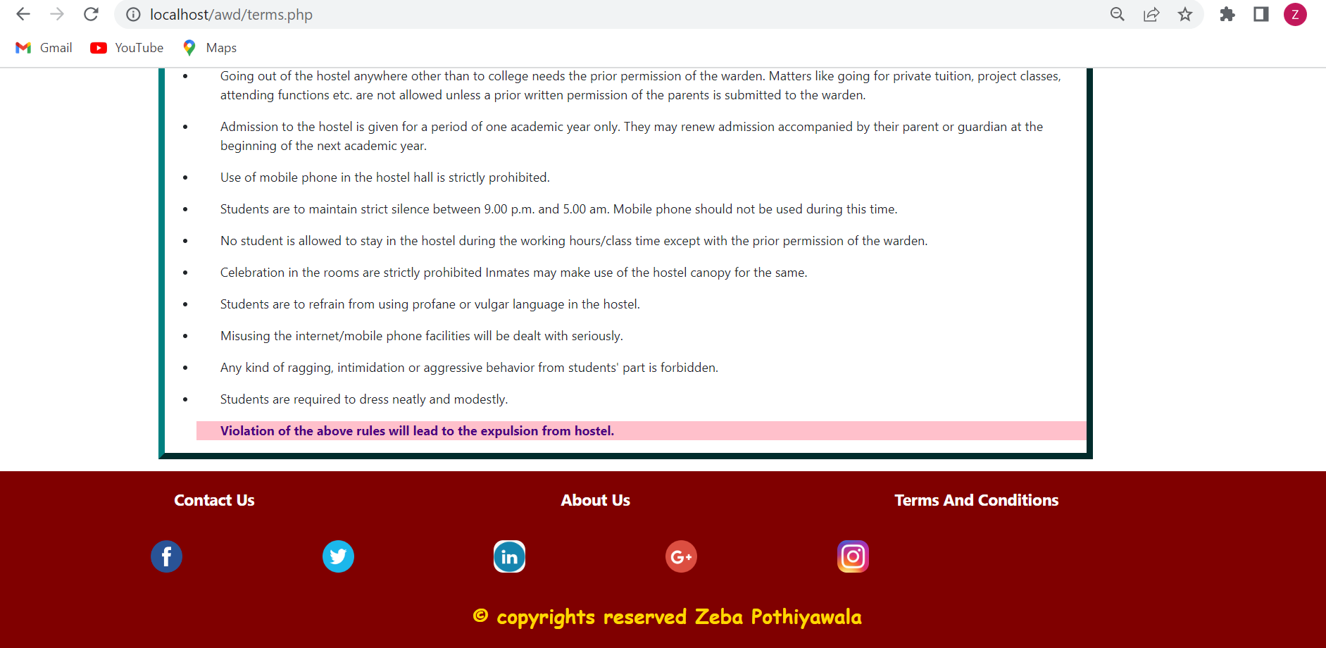

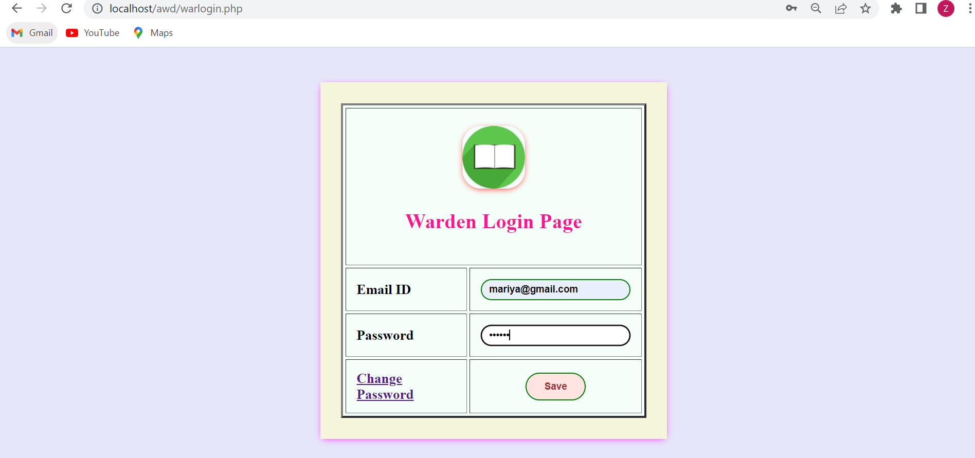

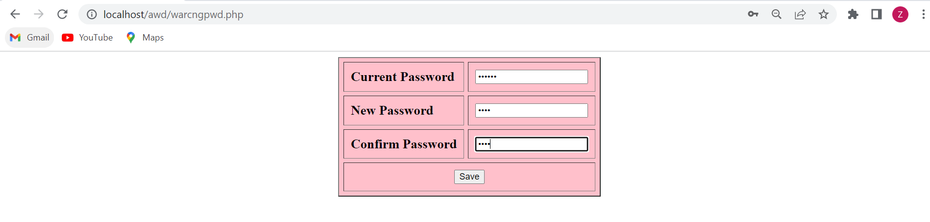

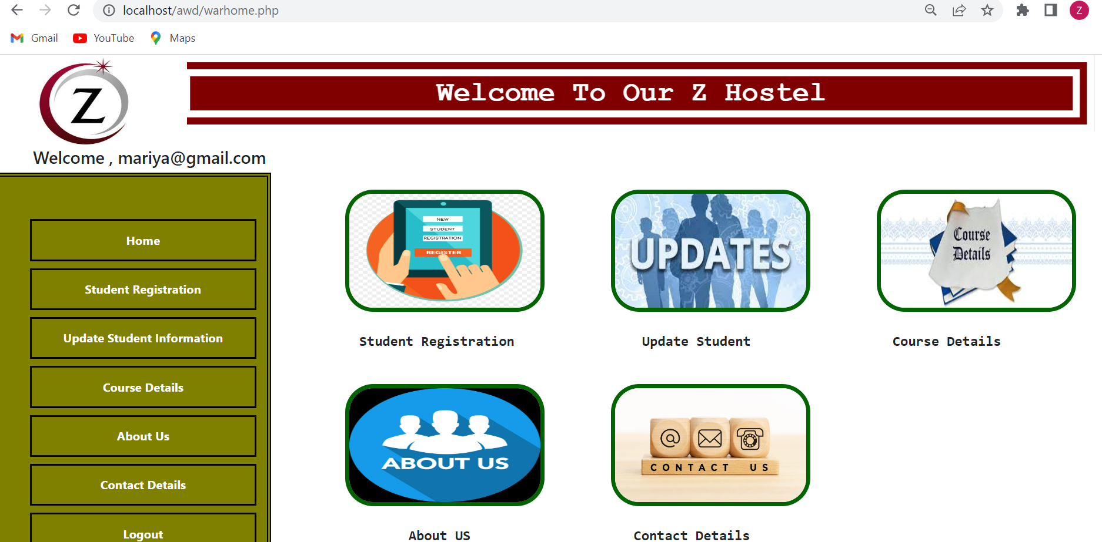



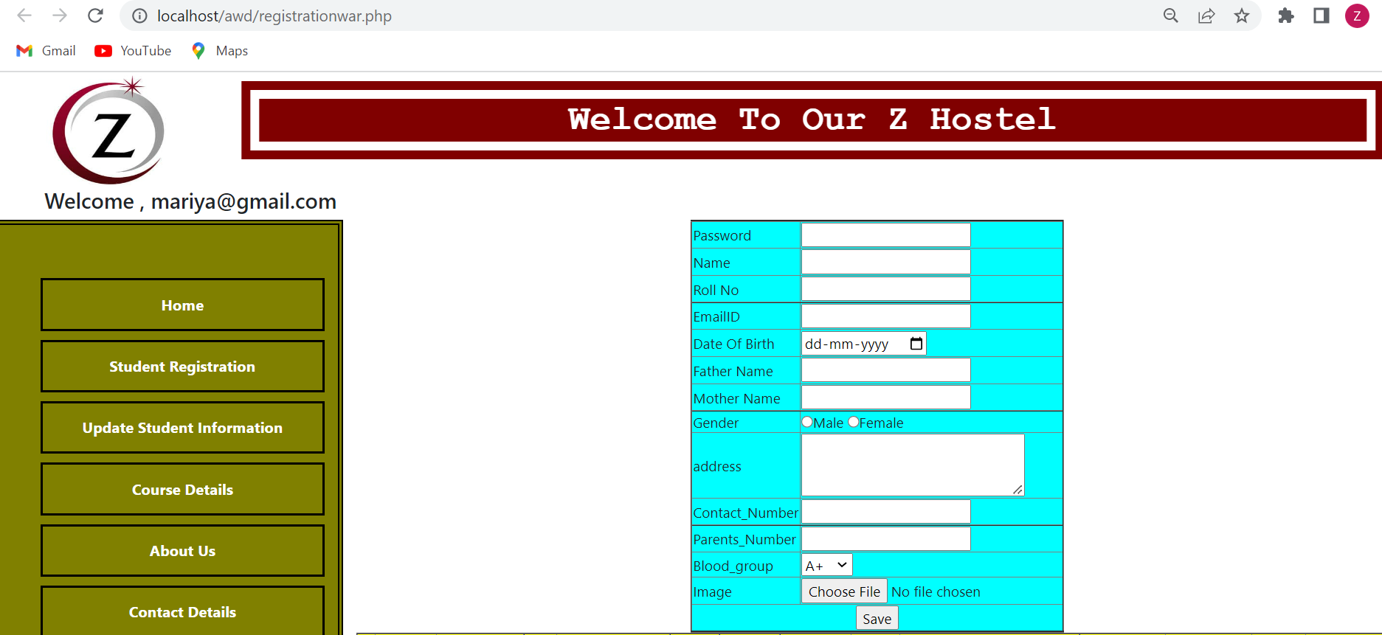

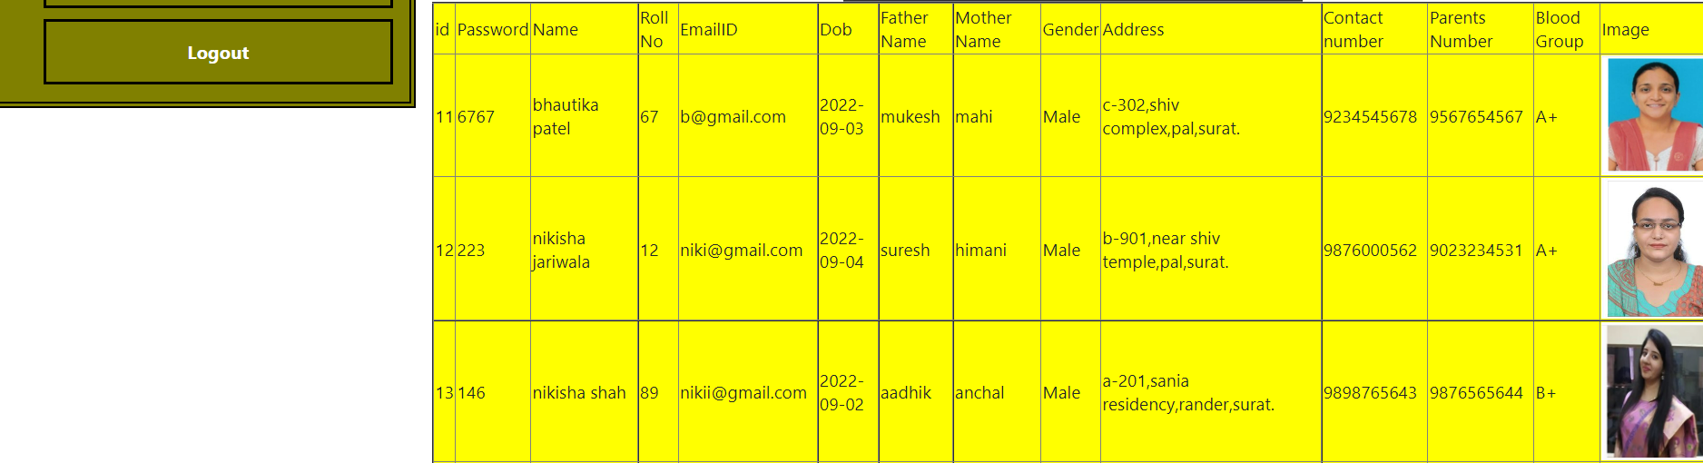

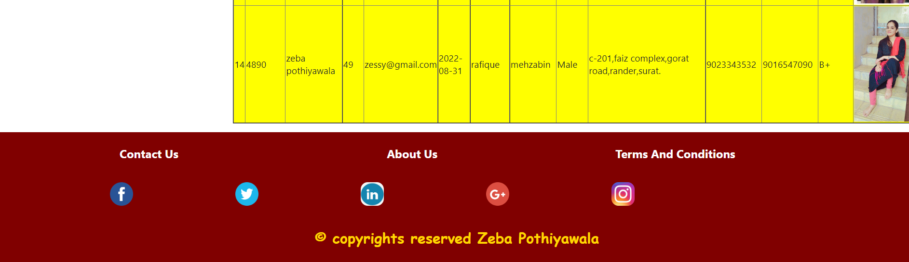

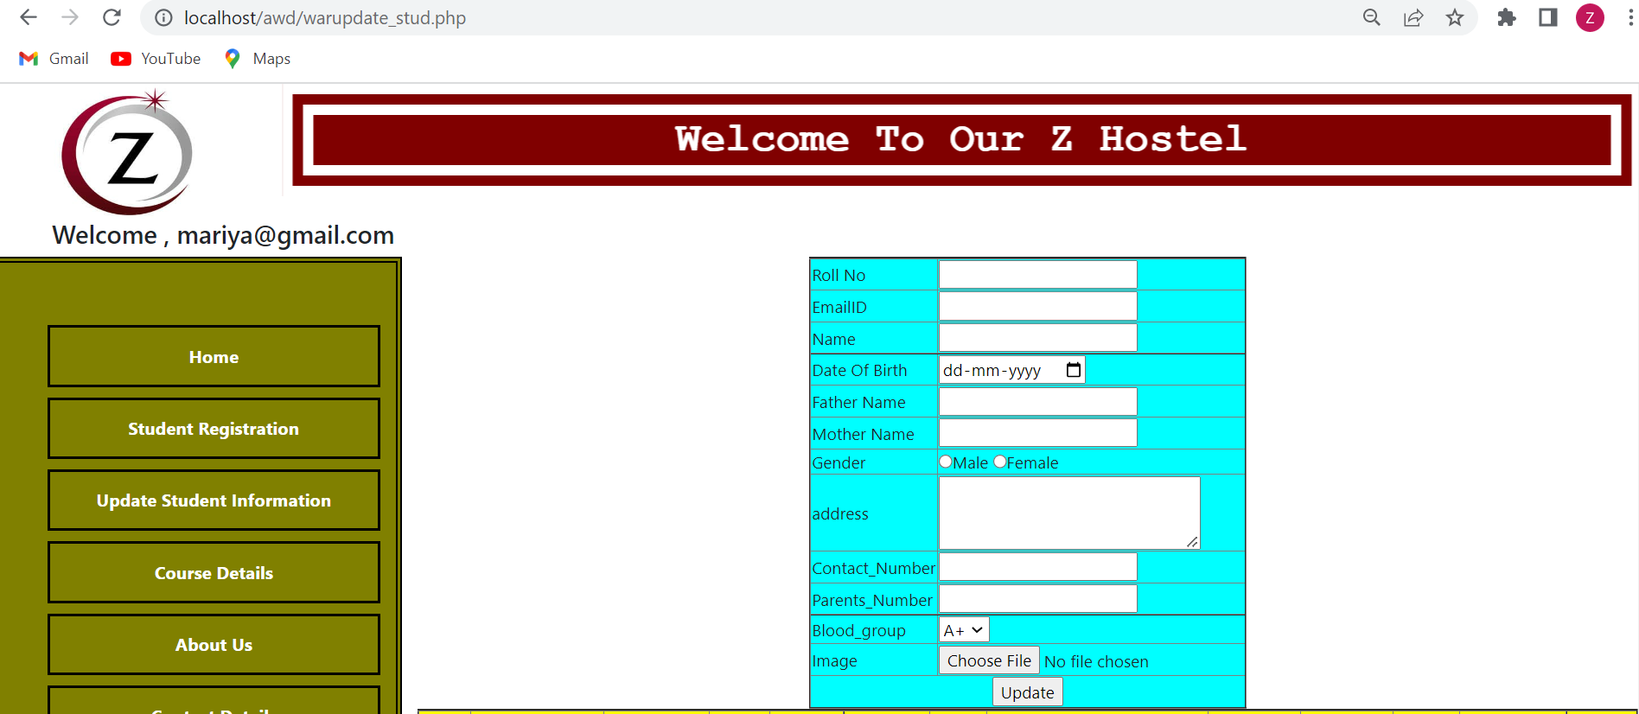

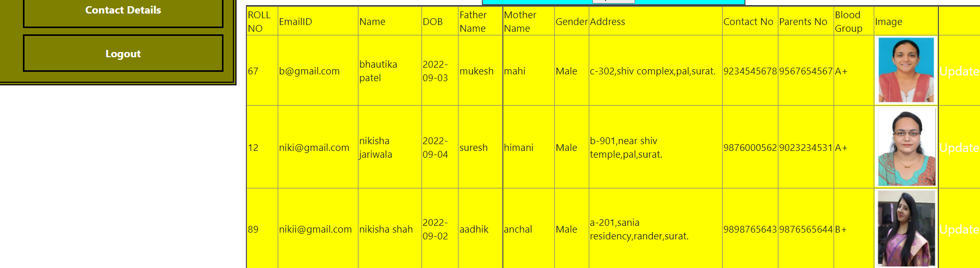

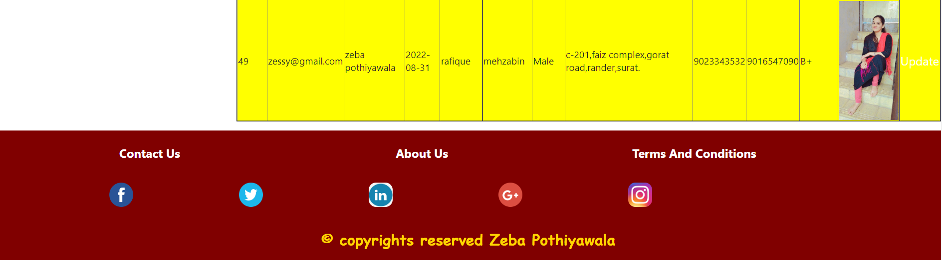

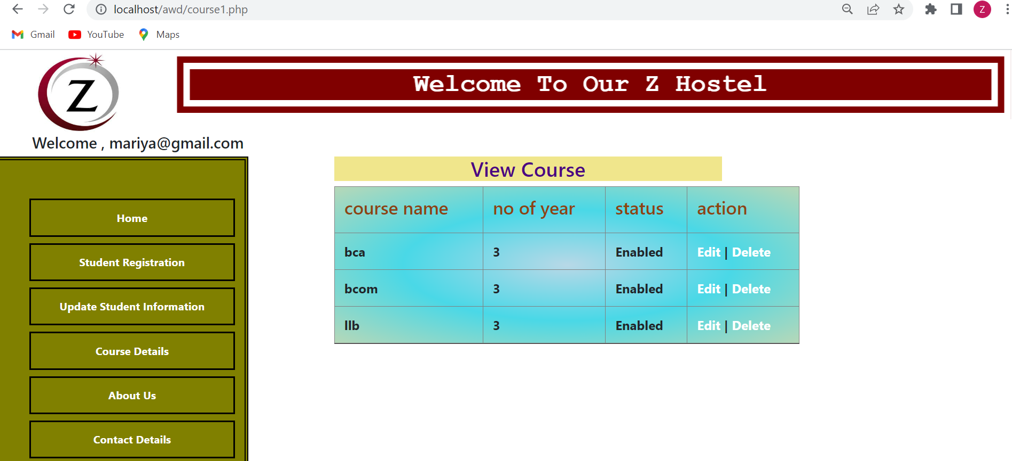



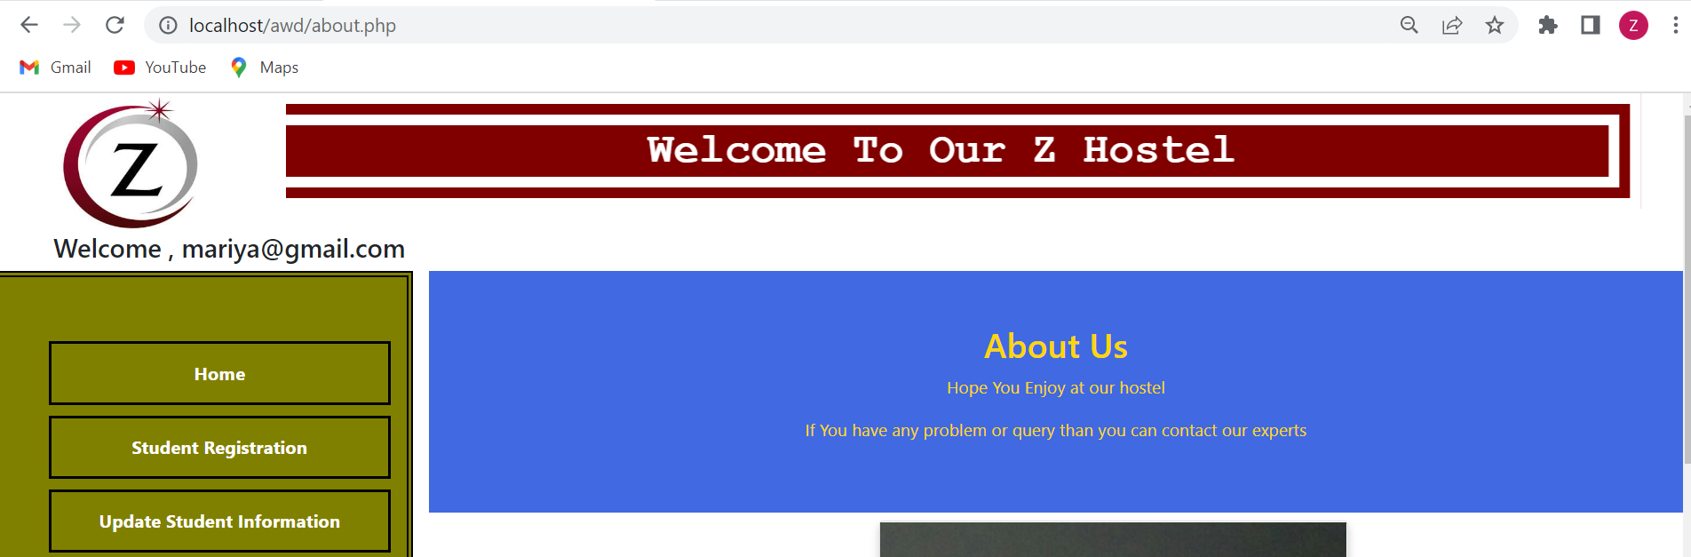

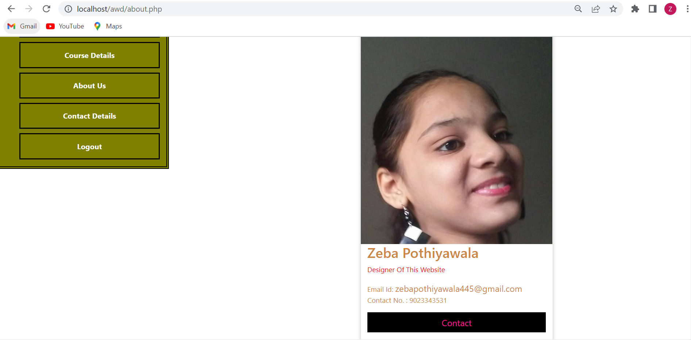



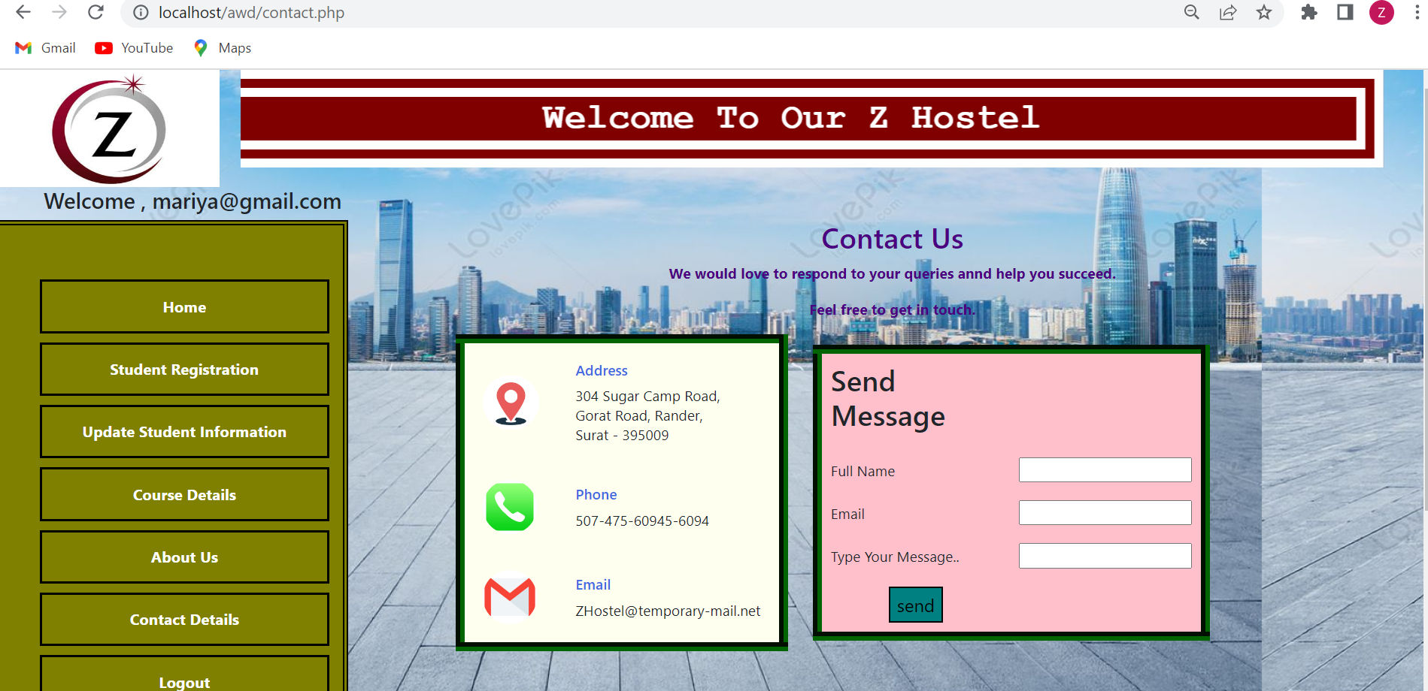

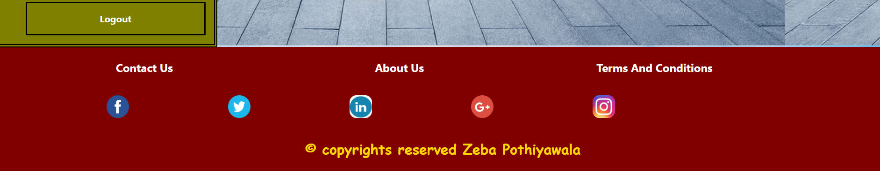

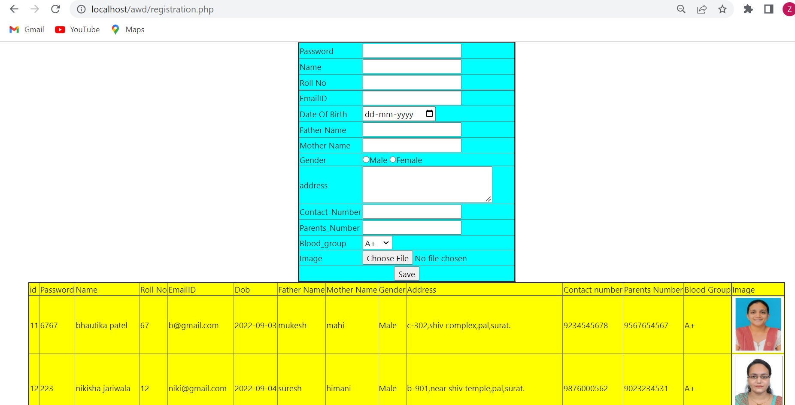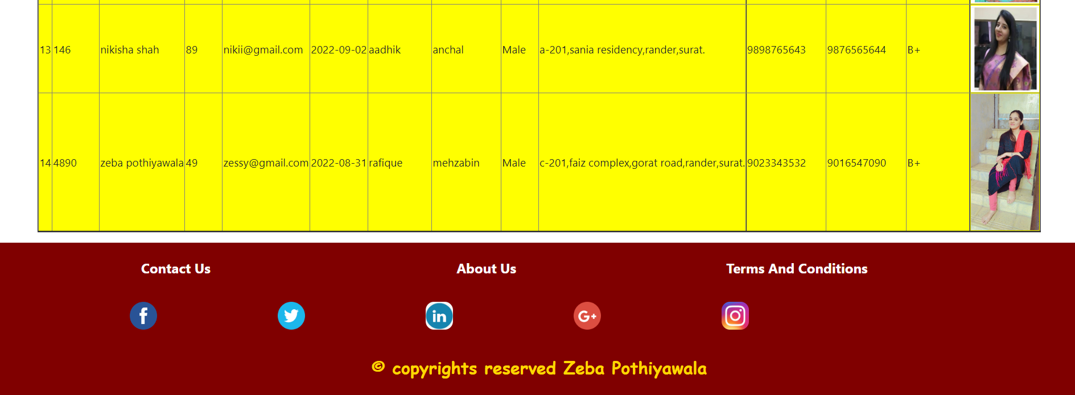

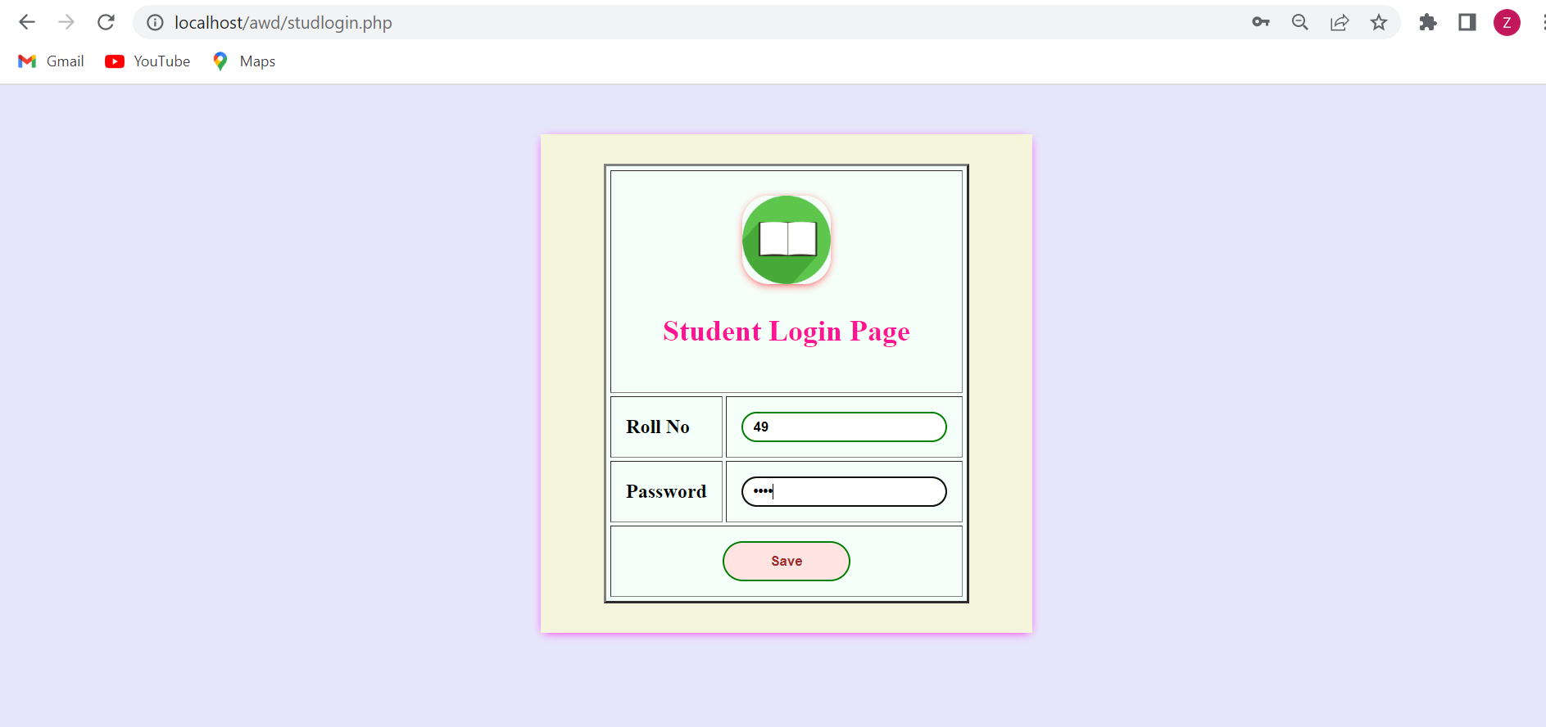

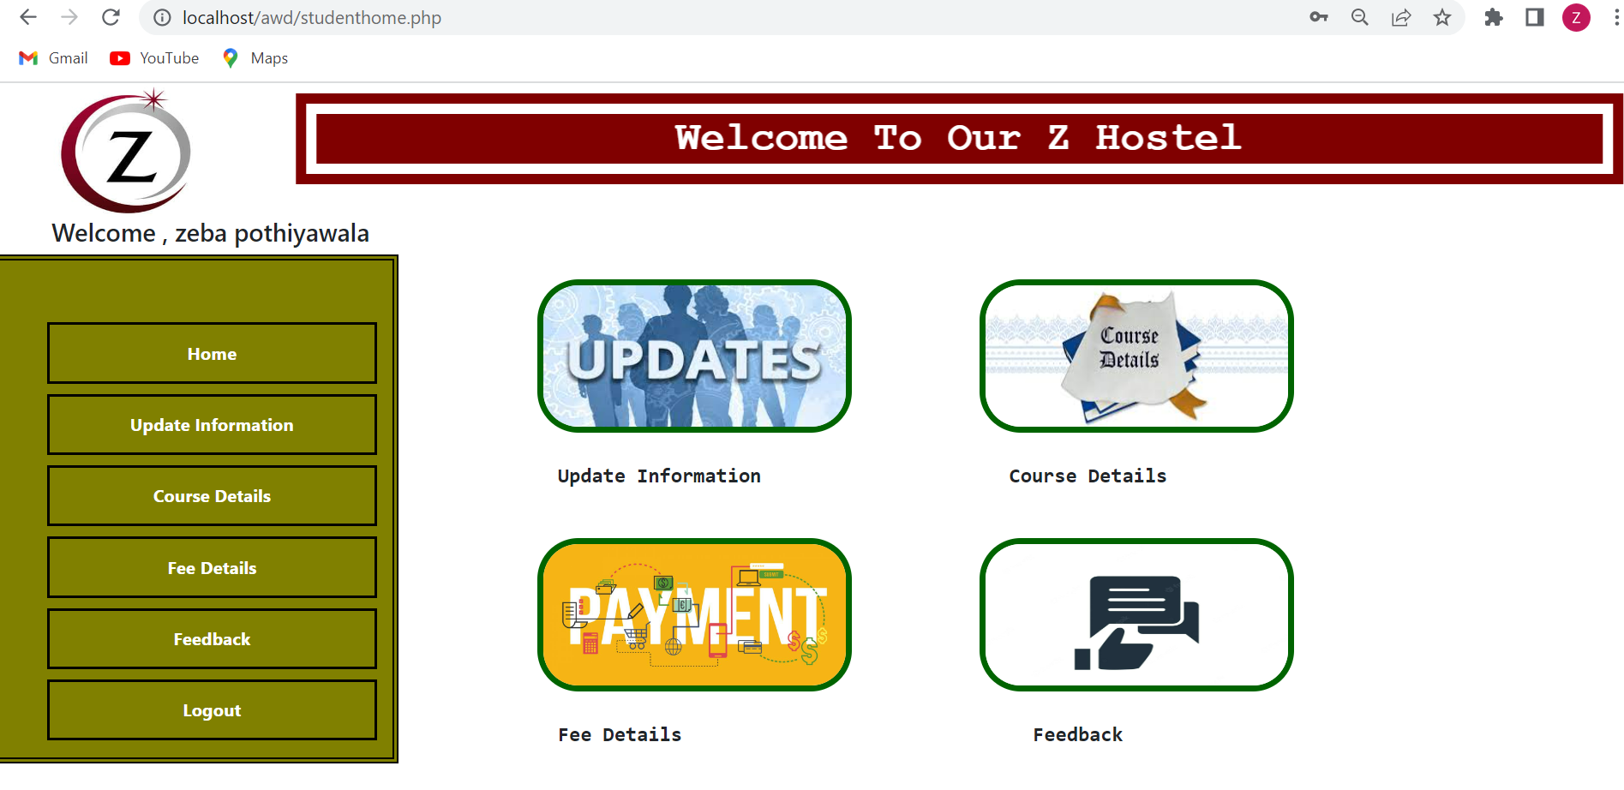



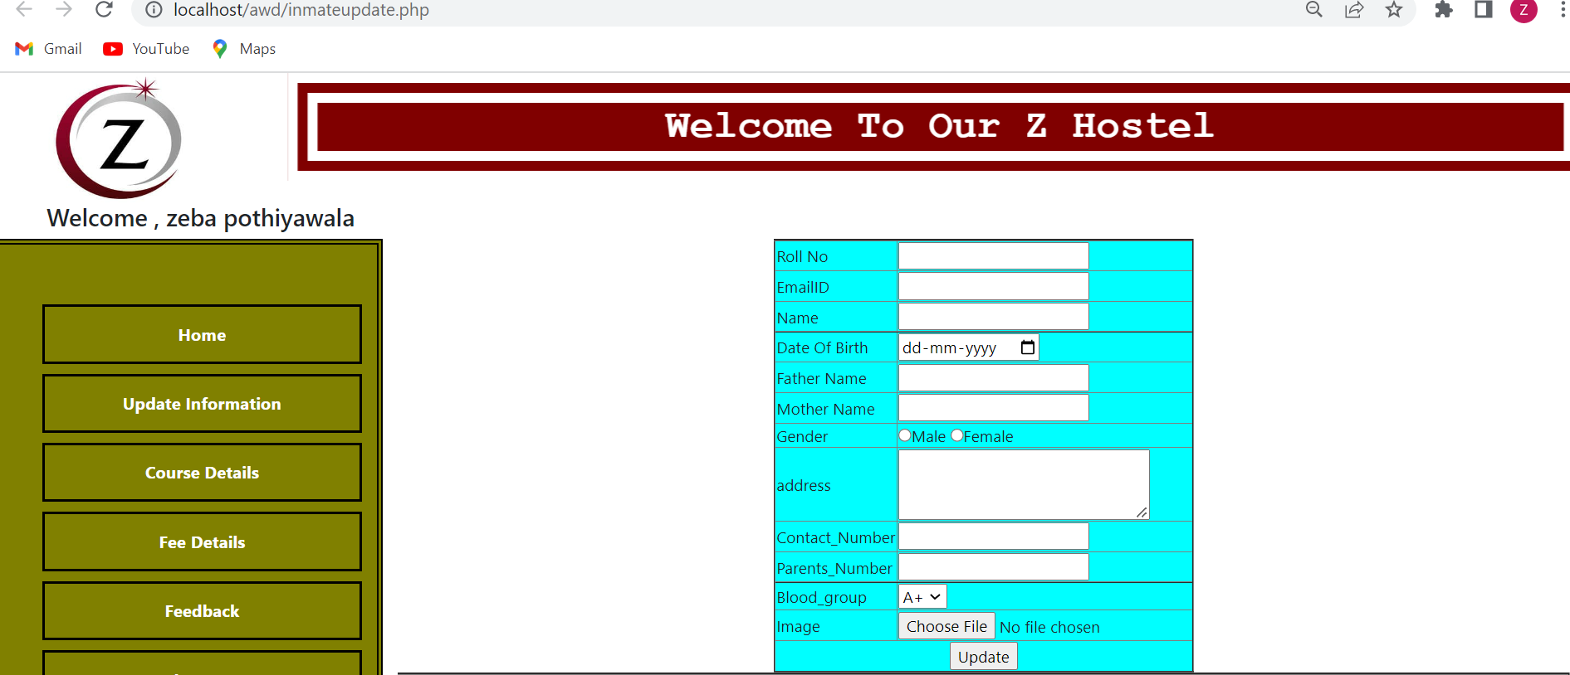

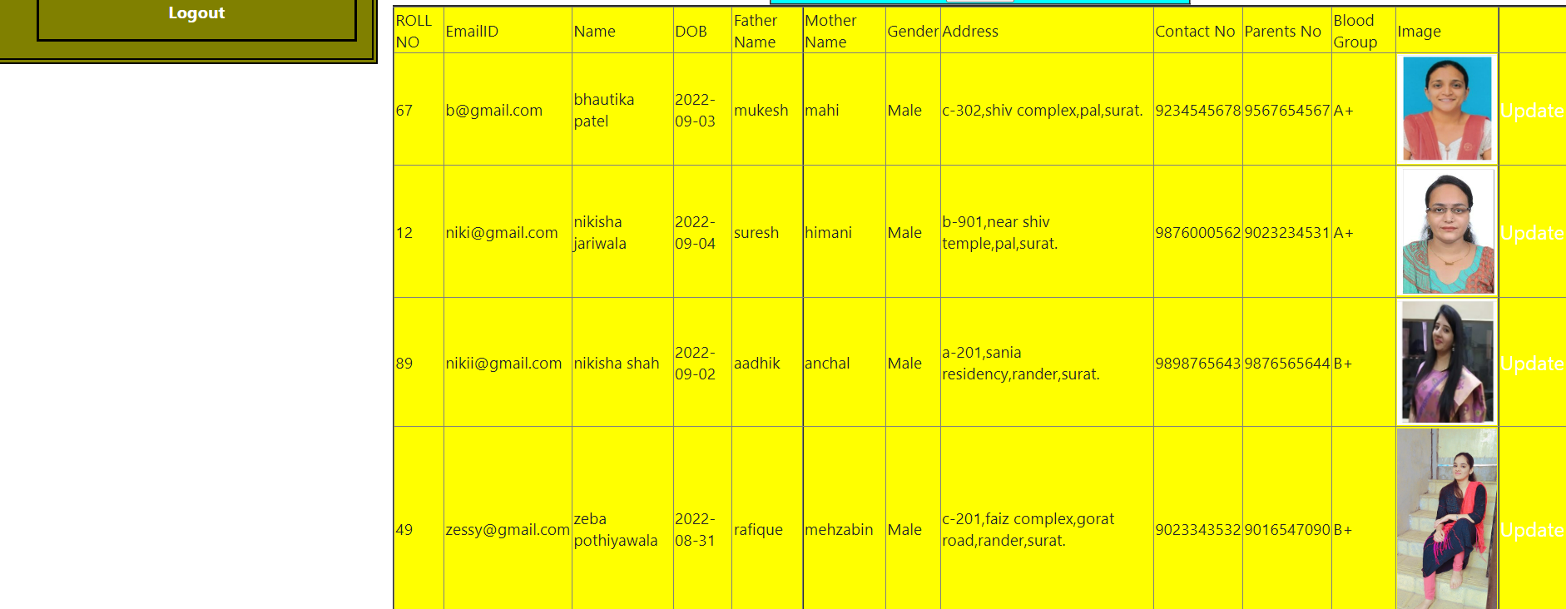



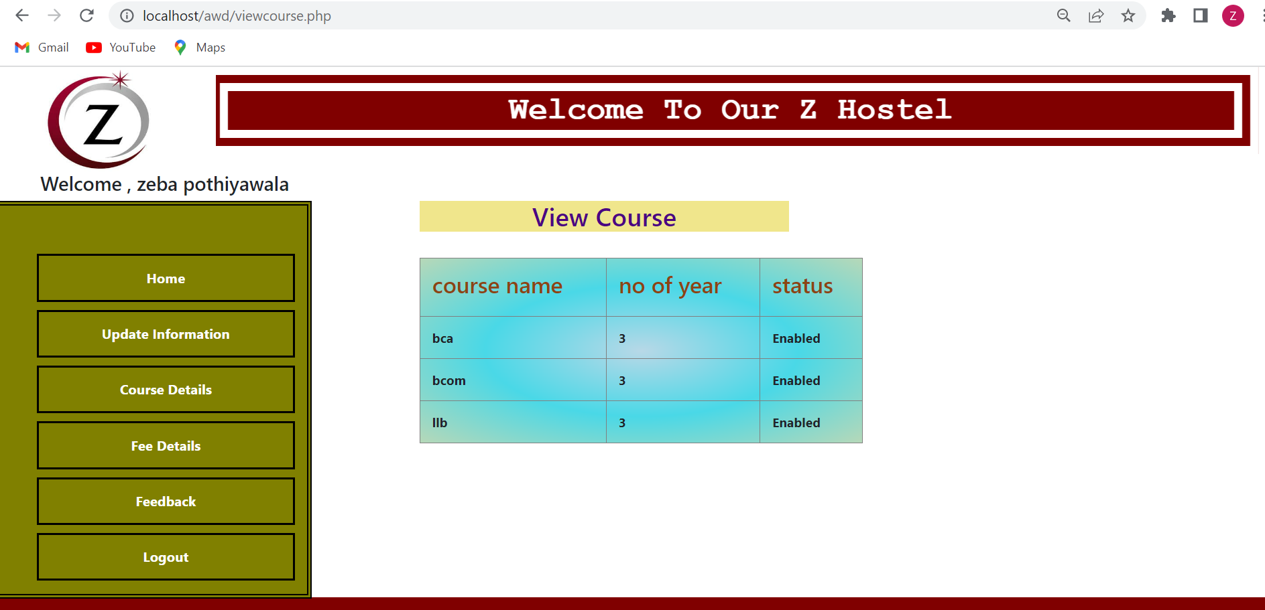



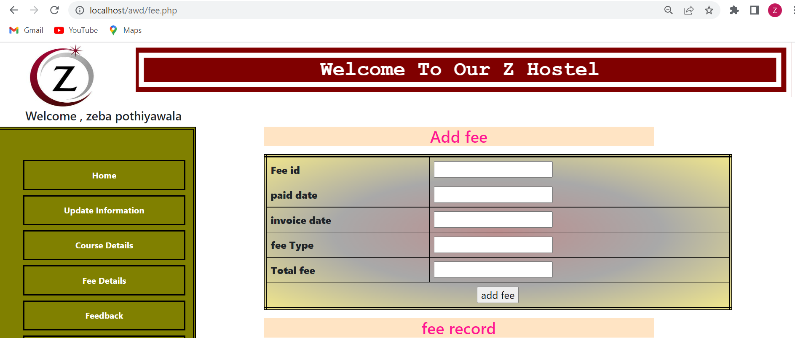

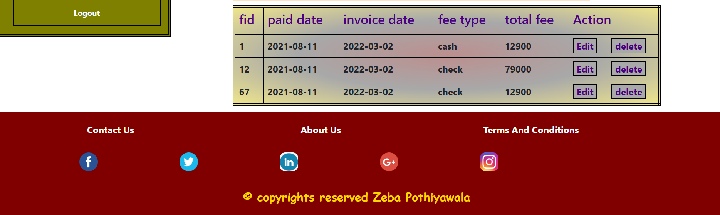

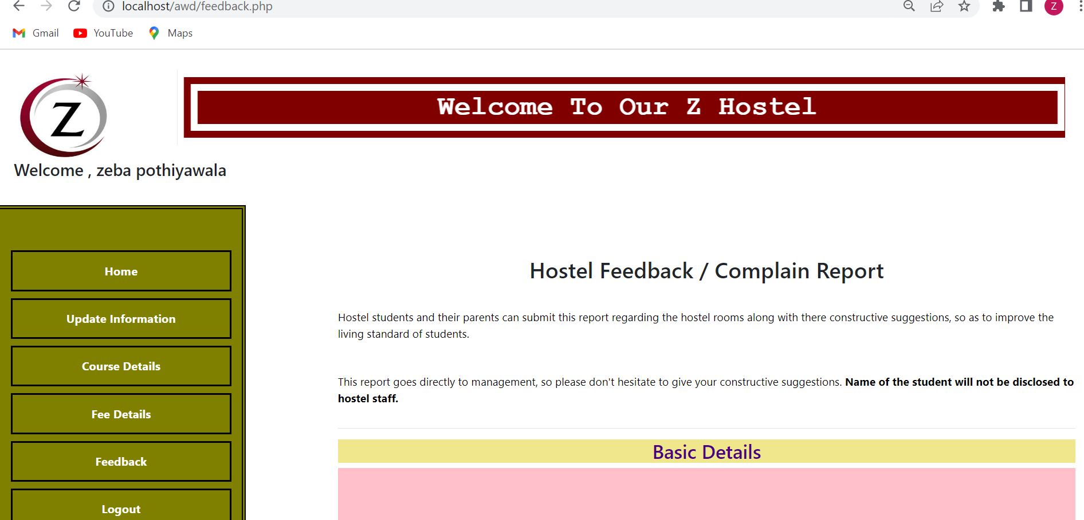

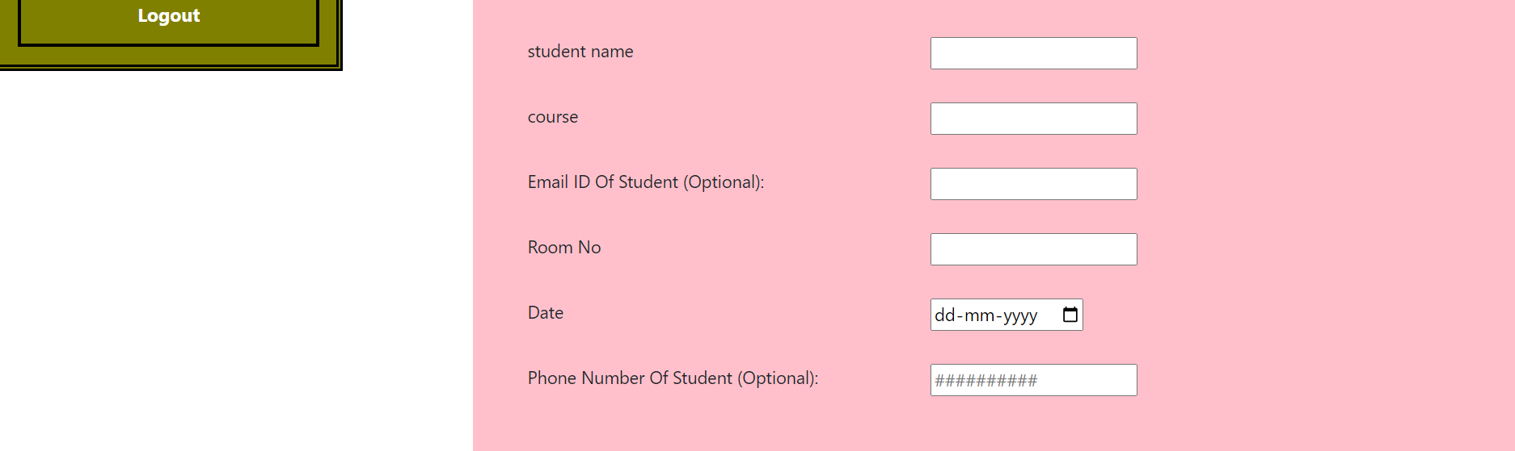

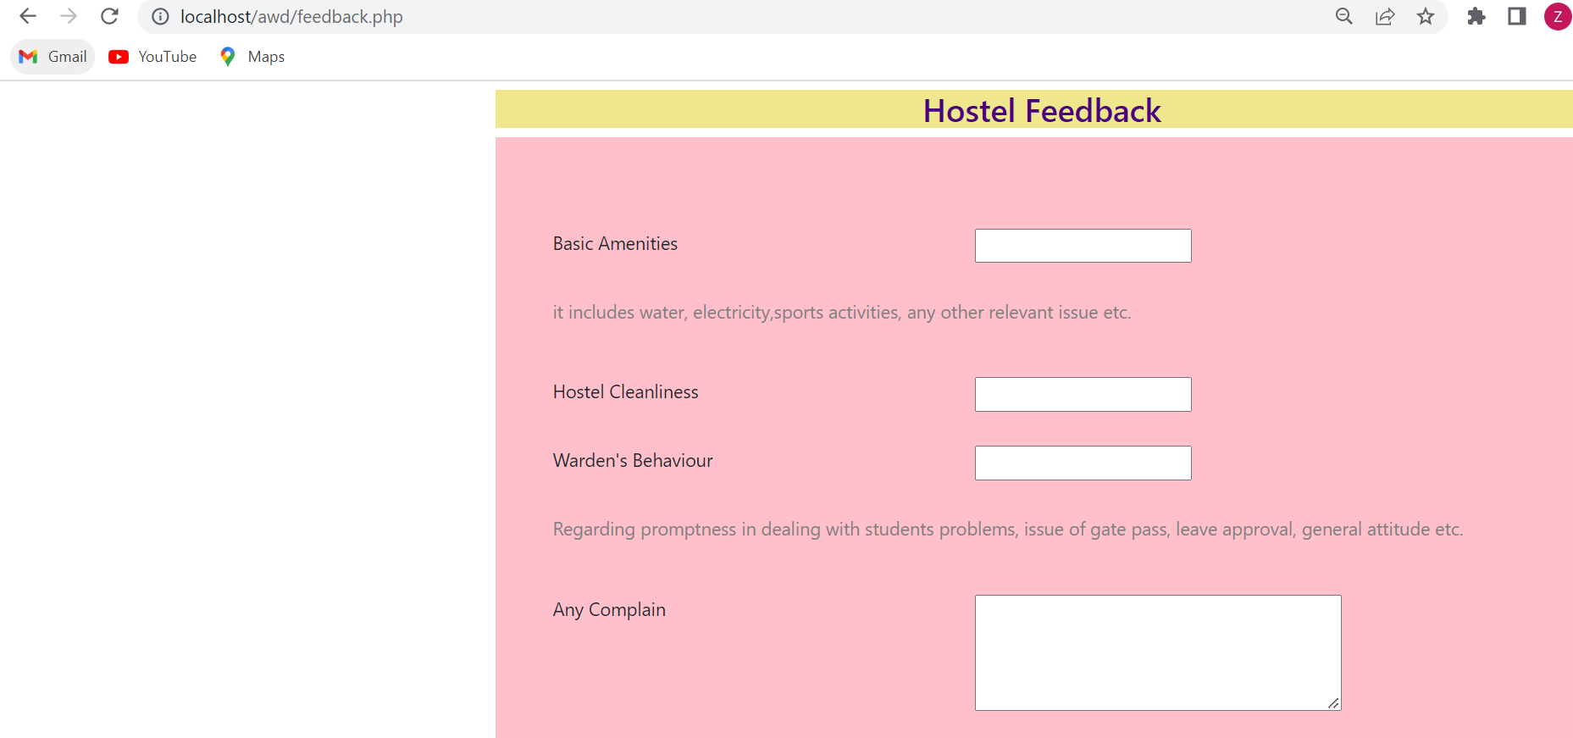

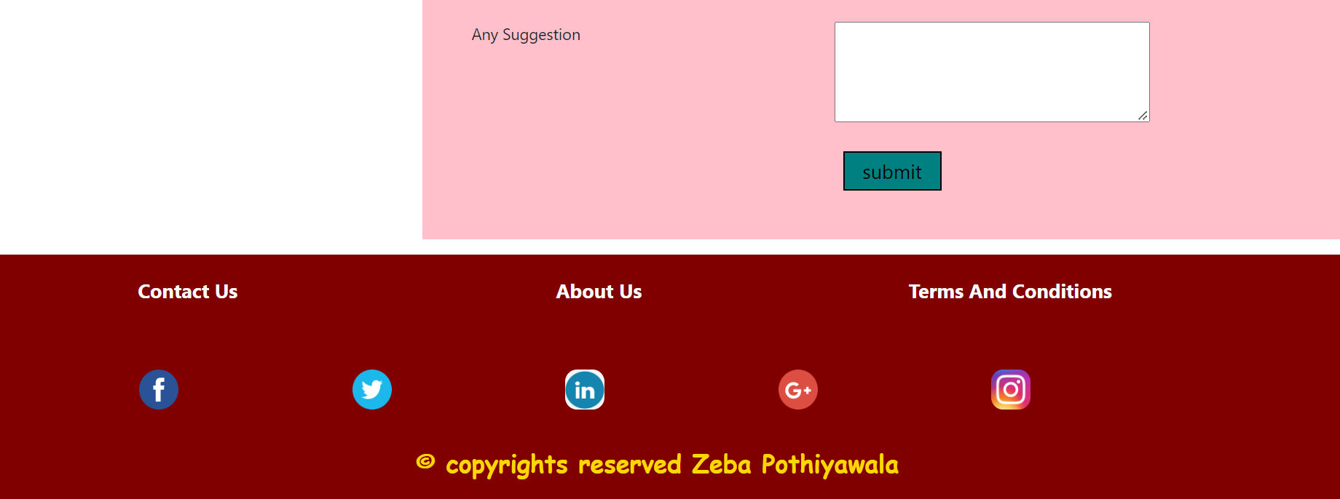

**Future Enhancement**

✪ There are many additional feature, which can be planned to be incorporated

during the future enhancement of this project.

✪ the future version of this project can handle the accounting of the hostel.

✪ the future version can be improved to provide functionality of working as in

a general-purpose hotel too.

✪ In future also we can add a module satisfying the restaurant in the hostel.

✪ PDF, csv reporting will be integrated for more reliability.

✪ The project has been designed in such manner by which, new changes will be

managed by adding a single module.

**References**

✪ [www.google.com](http://www.google.com)

✪ [www.youtube.com](http://www.youtube.com)

✪ <https://www.slideshare.net/kawsher11/hostel-management-134903687>

✪ <https://www.slideshare.net/PRIYANKMZN/hostel-management-system-5>

✪ [https://projectworlds.in/free-projects/php-projects/hostel-management- system-project-in-php/](https://projectworlds.in/free-projects/php-projects/hostel-management-%20%20%20%20%20%20%20%20%20%20%20%20%20%20system-project-in-php/)